EDITORS NOTE: Table of contents tables will be removed from individual clauses. The TOC below is for draft review purposes only.
8 Spatial reference frames 117
8.1 Introduction 117
8.2 Spatial coordinate systems 117
8.3 Spatial reference frame 118
8.3.1 Specification 118
8.3.2 SRF specification elements 118
8.4 SRF induced surface reference frame 120
8.5 SRF templates 121
8.5.1 Introduction 121
8.5.2 Celestiocentric SRF 122
8.5.3 Local space rectangular 3D SRF 123
8.5.4 Local space rectangular 2D SRF 124
8.5.5 Celestiodetic SRF 125
8.5.6 Local tangent plane 3D SRF 126
8.5.7 Local azimuthal spherical tangent plane SRF 127
8.5.8 Surface local azimuthal tangent plane SRF 128
8.5.9 Azimuthal 2D SRF 129
8.5.10 Local cylindrical tangent plane SRF 130
8.5.11 Polar 2D SRF 131
8.5.12 Celestiomagnetic SRF 132
8.5.13 Equatorial inertial SRF 132
8.5.14 Solar ecliptic SRF 133
8.5.15 Solar equatorial SRF 133
8.5.16 Solar magnetospheric SRF 134
8.5.17 Solar magnetic SRF 134
8.5.18 Heliospheric Aries ecliptic SRF 135
8.5.19 Heliospheric Earth ecliptic SRF 135
8.5.20 Heliospheric Earth equatorial SRF 136
8.5.21 Mercator SRF 136
8.5.22 Oblique Mercator SRF 137
8.5.23 Transverse Mercator SRF 138
8.5.24 Lambert conformal conic SRF 139
8.5.25 Polar stereographic SRF 140
8.5.26 Equidistant cylindrical SRF 141
8.6 SRFs 141
8.7 SRF sets 146

Figure 8.1 — A spatial embedding of a surface CS 117

Table 8.1 — Compatible CS types 118
Table 8.2 — SRFT specification elements 121
Table 8.3 — SRFT directory 122
Table 8.4 — Celestiocentric SRFT 123
Table 8.5 — Local space rectangular 3D SRFT 123
Table 8.6 — Local space rectangular 2D SRF template 124
Table 8.7 — Celestiodetic SRFT 125
Table 8.8 — Local tangent plane 3D SRFT 126
Table 8.9 — Local azimuthal spherical tangent plane SRFT 127
Table 8.10 — Surface local azimuthal tangent plane SRFT 128
Table 8.11 — Azimuthal 2D SRFT 129
Table 8.12 — Local cylindrical tangent plane SRFT 130
Table 8.13 — Polar 2D SRFT 131
Table 8.14 — Celestiomagnetic SRFT 132
Table 8.15 — Equatorial inertial SRFT 132
Table 8.16 — Solar ecliptic SRFT 133
Table 8.17 — Solar equatorial SRFT 133
Table 8.18 — Solar magnetospheric SRFT 134
Table 8.19 — Solar magnetic SRFT 135
Table 8.20 — Heliospheric Aries ecliptic SRFT 135
Table 8.21 — Heliospheric Earth ecliptic SRFT 136
Table 8.22 — Heliospheric Earth equatorial SRFT 136
Table 8.23 — Mercator SRFT 137
Table 8.24 — Oblique Mercator SRFT 137
Table 8.25 — Transverse Mercator SRFT 138
Table 8.26 — Lambert conformal conic SRFT 139
Table 8.27 — Polar stereographic SRFT 140
Table 8.28 — Equidistant cylindrical SRFT 141
Table 8.29 — SRF specification elements 141
Table 8.30 — SRFs 142
Table 8.31 — SRF set specification elements 146
Table 8.32 — SRF sets 146
Table 8.33 — SRF set member specification elements 149
Table 8.34 — Explicit specifications of SRF set members 149
Table 8.35 — Implicit specifications of SRF set members 151
Table 8.36 — GTRS indexing scheme and set members directory 153
Table 8.37 — GTRS indexing scheme and set members: 88º-90º north 153
Table 8.38 — GTRS indexing scheme and set members: 86º-88º north 153
Table 8.39 — GTRS indexing scheme and set members: 84º-86º north 154
Table 8.40 — GTRS indexing scheme and set members: 80º-84º north 154
Table 8.41 — GTRS indexing scheme and set members: 78º-80º north 154
Table 8.42 — GTRS indexing scheme and set members: 71º-78º north 154
Table 8.43 — GTRS indexing scheme and set members: 60º-71º north 155
Table 8.44 — GTRS indexing scheme and set members: 60º south - 60º north 155
Table 8.45 — GTRS indexing scheme and set members: 71º-60º south 158
Table 8.46 — GTRS indexing scheme and set members: 78º-71º south 159
Table 8.47 — GTRS indexing scheme and set members: 80º-78º south 159
Table 8.48 — GTRS indexing scheme and set members: 84º-80º south 159
Table 8.49 — GTRS indexing scheme and set members: 86º-84º south 159
Table 8.50 — GTRS indexing scheme and set members: 88º-86º south 160
Table 8.51 — GTRS indexing scheme and set members: 90º-88º south 160
Table 8.52 — MTM (body) indexing scheme and set members: northern hemisphere 160
Table 8.53 — MTM (body) indexing scheme and set members: southern hemisphere 160
Table 8.54 — MTM (pole) indexing scheme and set members: northern hemisphere 160
Table 8.55 — MTM (pole) indexing scheme and set members: southern hemisphere 161
Table 8.56 — UPS indexing scheme and set members: northern hemisphere 161
Table 8.57 — UPS indexing scheme and set members: southern hemisphere 161
Table 8.58 — UTM indexing scheme and set members: northern hemisphere 161
Table 8.59 — UTM indexing scheme and set members: southern hemisphere 162

Spatial reference frames

Introduction
A spatial reference frame is a spatial coordinate system for a region of the space of an object formed by the binding of an abstract coordinate system to the linear embedding specified by an ORM. A full specification includes values for the CS parameters and a specification of the region of the space of the object. In some cases, some the CS parameters are bound by ORM parameters. In particular, a CS based on an oblate spheroid (or sphere) must match the parameters of the oblate spheroid (or sphere) RD of the ORM.
A spatial reference frame template is the basis for realizing spatial reference frames that share the same CS, similar ORMs, and the same structure in the binding of CS parameter values. Spatial reference frames may be organized into specified sets so as to form an atlas for a large region of space. This International Standard specifies a collection of spatial reference frame templates, realizations of those templates, and sets of those realizations.

Spatial coordinate systems
Once an embedding of R^{m} is established, any N-dimensional CS for R^{m} (m = 1, 2, or 3) specifies an N-dimensional spatial CS that associates coordinates in coordinate space to points in object-space. This association is a binding of a CS via a spatial embedding. This is illustrated in Figure 8.1 that illustrates a spatial surface CS bound with an embedding of R³ to the 3D space of an object. In this illustration, a surface coordinate (u, v) in coordinate-space is associated to a position (x, y, z) in the abstract position-space R³. That position is then identified with a position in the space of an object via the embedding of R³ determined by the selection of an origin and three unit points.
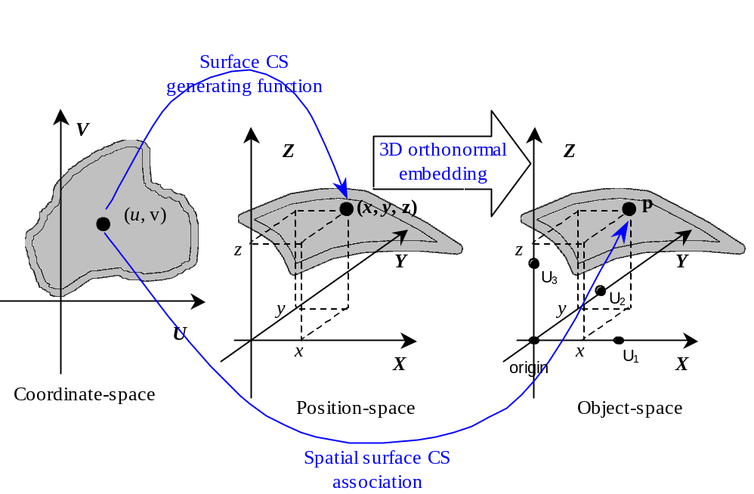
Figure 8.1 — A spatial embedding of a surface CS

Spatial reference frame

Specification
A spatial reference frame (SRF) is a specification of an ORM together with a compatible spatial CS, where coordinates uniquely specify a position with respect to the spatial object for which that ORM was specified. A specification of an SRF includes:
- an ORM,
- a spatial CS compatible with the ORM,
- a binding of all parameters of the spatial CS,
- (optionally) k^{th}–coordinate names, and
- (optionally) additional restrictions on the domain of valid coordinates in that spatial CS.
Spatial CS compatibility and the other elements of the specification of an SRF are defined in the following clauses.

SRF specification elements

ORM and CS compatibility
The compatible CS type of the CS element of an SRF depends on the dimension of the ORM. The dimension of an ORM is defined as the dimension of the RD specification of the ORM. The compatible CS types by ORM dimension are specified in Table 8.1.
Table 8.1 — Compatible CS types
ORM dimension | Compatible CS types
1D | 1D CS
2D | Curve CS  2D CS
3D | Curve CS  Surface CS  3D CS

The use of surface CSs or 3D CSs that are based on an oblate spheroid (or sphere) are further restricted to ORMs based on an oblate spheroid (or respectively, sphere) RD.
The surface CSs that are based on an oblate spheroid (or sphere) are:
- surface geodetic, and
- all map projections.
The 3D CSs that are based on an oblate spheroid (or sphere) are:
- geodetic 3D, and
- all augmented map projections.
As a further restriction, some map projections are based on spheres only. These include:
- CS_MP_OBLIQUE_MERCATOR, and
- CS_MP_EQUIDISTANT_CYLINDRICAL.

CS parameter binding
All CS parameter values must be specified. In the case of a combination of a CS and an ORM based on an oblate spheroid (or sphere), the major semi-axis and minor semi-axis (or equivalently, the inverse flattening) (or respectively, sphere radius) of the ORM and CS shall match.

Coordinate names
A CS specification (see 5.4) includes the coordinate symbols with common names (if any). A specification of an SRF may optionally assign SRF-specific names to the k^{th}-coordinates. The name assignment shall reflect the common use in the intended application domain.
EXAMPLE 1 For a spherical CS, the assignment of SRF-specific names to the k^{th}-coordinates of “right ascension” for λ, “declination” for θ , and “radius” for ρ.

Coordinate valid region
A CS specification (see 5.4) includes the specification of the domain and range where the generating function (or mapping equations) and its inverse(s) are defined. An SRF specification may further restrict the domain. A valid region is a restriction of the domain of the generating function (or mapping equations) for a CS as used in a SRF. An extended valid region is a second valid region that contains the first valid region as a subset. The specification of these restrictions is important for several (SRF specific) reasons:
- If the ORM is local, the restrictions are used to model, in coordinate-space, the local region of the space of the object.
- If the CS is a map projection or an augmented map projection, the restrictions are used to bound or otherwise limit distortions (see 5.3.3.1).
- The SRF may be used in conjunction with other SRFs to form an atlas for a large region. In this case, the restrictions are used to control the pair-wise overlap of the spatial coverage of members of the SRF collection.
- If the CS generating function (or map projection mapping equations) or the inverse function(s) have been implemented with a numerical approximation, the restrictions are used to control error bounds.
- Any combination of the reasons above.
The extended valid region is used primarily for overlapping regions in forming an atlas as in (c) above. Not all properties of the SRF that are true in the valid region will necessarily be true in the extended valid region. For example, a distortion error bound that holds in the valid region may not hold in the extended valid region.
A valid region may be described and/or specified. A valid region description is a descriptive statement of the region such as the spatial boundary of a named political entity.
EXAMPLE 2 “The German state of Baden-Wurttemberg.” and “The Baltic Sea.” are valid region descriptions.
In this International Standard, a valid region specification is a finite (or empty) list of coordinate constraints of the form:
k^{th}-coordinate belongs to a non-empty interval of real numbers .
An extended valid region specification is a finite (or empty) list of coordinate constraints of the form:
k^{th}-coordinate belongs to an interval of real numbers 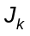, where has been specified and 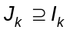.
In the case of an SRF with an oblate spheroid (or sphere) based ORM, celestiodetic coordinates may be similarly constrained. In particular, a valid region specification for a map projection based SRF may specify coordinate constraints for easting, northing, latitude, and/or longitude.
EXAMPLE 3 The SRF is based on a Mercator map projection (see SRFT_ MERCATOR).
Valid region specification: 0 ≤ easting ≤ 10 000 000, 0 ≤ northing ≤ 500 000
Extended valid region specification: -100 < easting, -100 < northing
In this example 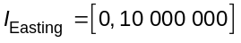and 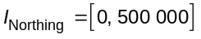are closed bounded intervals, and 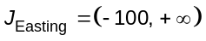and 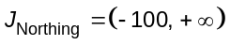are open semi-bounded intervals.
EXAMPLE 4 The SRF is based on a transverse Mercator map projection (see SRFT_TRANSVERSE_MERCATOR).
Valid region specification: -78º ≤ longitude < -72º, 0º ≤ latitude < 84º
Extended valid region specification: -78,5º ≤ longitude < -71,5º
In this example 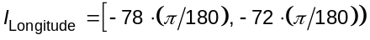and 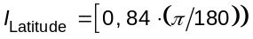are left-closed, right-open bounded intervals, as is . 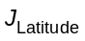is not specified. This indicates that there are no constraints for latitude (except for the CS domain definition) in the extended valid region.

SRF induced surface reference frame
In the case of an SRF specified with the combination of a 3D ORM and a 3D CS, the 3D CS induces a surface CS on each coordinate surface (see 5.2.4.2). If the 3D CS has a coordinate that can be identified as a vertical coordinate for the SRF, then the coordinate surface for the zero value of the vertical coordinate (if defined) is of special interest and the surface CS induced on that coordinate surface specifies an SRF surface CS.
The CS_3D_GEODETIC 3rd-coordinate (h: ellipsoidal height), and the 3rd-coordinate of any augmented map projection CS (h: ellipsoidal height) are identified in this International Standard as a vertical coordinate. When an SRF is specified with any of these 3D CSs, the h = 0 coordinate surface coincides with the surface of the oblate spheroid (or sphere) RD of the ORM. Any SRF based on these CSs intrinsically specifies the corresponding surface CS on the oblate spheroid (or sphere) RD surface.
In the case of other 3D CSs, a vertical coordinate may be specified in the coordinate name specification element of the SRF. In particular, the SRFT_3D_LOCAL_TANGENT_PLANE and in the SRFT_3D_LOCAL_CYLINDRICAL_TANGENT_PLANE the 3rd-coordinate is specified as the vertical coordinate.
SRF templates that are based on surface CSs that can be induced by a zero value vertical coordinate surface of an SRF based on a 3D CS are not separately specified. The induced surface CS is noted in the corresponding 3D CS based SRF template specification.
The zero value 3rd-coordinate surface of the 3D CS of the SRFT_LOCAL_AZIMUTHAL_SPHERICAL_TANGENT_PLANE induces the surface CS of the SRFT_SURFACE_LOCAL_AZIMUTHAL_TANGENT_PLANE. However, since that 3rd-coordinate is not specified as a vertical coordinate, the SRFT_SURFACE_LOCAL_AZIMUTHAL_TANGENT_PLANE has a separate specification.

SRF templates

Introduction
An SRF template (SRFT) is an abstraction of a set of specifications of SRFs that share the same CS and coordinate names, whose ORM components are similar, that model the same type of spatial object, and whose CS share the same binding rules. An SRF template allows for a consistent derivation of SRFs. It is not necessary that an appropriate SRFT be defined in order to define a new SRF; however in this International Standard all SRFs are derived from SRFTs.
The specification elements for SRFTs are defined in Table 8.2.
Table 8.2 — SRFT specification elements
Specification element | Definition
Label | The label (see 12.2.2).
Code | The code (see 12.2.3).
Description | A description including name as published or as commonly known.
Object type | One of: planet, satellite, star, non-celestial, abstract, Earth, and Sun. The relationships among these object types are specified in Figure 4.1.
ORM constraint | Criteria for allowable ORMs.
CS label | The label of a CS of compatible type.
CS coordinate names and/or symbols | SRF-specific names and/or symbols for the k^{th}-coordinate names and/or symbols, and a designation of the vertical coordinate if applicable.
Template parameters | CS and RD parameters, if any, and/or SRF parameters that are not specified by a CS parameter binding rule.
CS parameter binding rules | A set of rules for binding for CS parameters and RD class parameters, if any, and/or SRF parameters.
Coordinate valid region | Optional restriction of the domain of the CS to a valid region. If a valid region is specified, optionally an extended valid region. If both are unspecified, then there are no additional constraints on coordinate validity.
Notes | Optional, additional, non-normative information such as a description of the SRF structure, modelled region, intended use, and/or application domain.
Reference type | The reference type (see 12.2.5).
References | The references (see 12.2.5).

This International Standard specifies a collection of SRFTs as identified in Table 8.3. Additional SRFTs may be registered in accordance with Clause 12. Registered SRFs shall be derived only from standardized or registered SRFTs.
Table 8.3 — SRFT directory
CS type | Description | SRFT label
3D | Celestiocentric | SRFT_CELESTIOCENTRIC
3D | Local space rectangular | SRFT_3D_LOCAL_SPACE_RECTANGULAR
3D | Celestiodetic | SRFT_CELESTIODETIC
3D | Local tangent plane | SRFT_3D_LOCAL_TANGENT_PLANE
3D | Local azimuthal spherical tangent plane | SRFT_LOCAL_AZIMUTHAL_SPHERICAL_-TANGENT_PLANE
3D | Local cylindrical tangent plane | SRFT_LOCAL_CYLINDRICAL_TANGENT_PLANE
3D | Celestiomagnetic | SRFT_CELESTIOMAGNETIC
3D | Equatorial inertial | SRFT_EQUATORIAL_INERTIAL
3D | Solar ecliptic | SRFT_SOLAR_ECLIPTIC
3D | Solar equatorial | SRFT_SOLAR_EQUATORIAL
3D | Solar magnetospheric | SRFT_SOLAR_MAGNETOSPHERIC
3D | Solar magnetic | SRFT_SOLAR_MAGNETIC
3D | Heliospheric Aries ecliptic | SRFT_HELIOSPHERIC_ARIES_ECLIPTIC
3D | Heliospheric Earth ecliptic | SRFT_HELIOSPHERIC_EARTH_ECLIPTIC
3D | Heliospheric Earth equatorial | SRFT_HELIOSPHERIC_EARTH_EQUATORIAL
Surface | Surface celestiodetic (induced) | SRFT_CELESTIODETIC
Surface | Surface local tangent plane (induced) | SRFT_3D_LOCAL_TANGENT_PLANE
Surface | Surface local azimuthal tangent plane | SRFT_SURFACE_LOCAL_AZIMUTHAL_-TANGENT_PLANE
Surface | Surface local polar tangent plane (induced) | SRFT_LOCAL_CYLINDRICAL_TANGENT_PLANE
2D | Local space rectangular | SRFT_2D_LOCAL_SPACE_RECTANGULAR
2D | Azimuthal | SRFT_2D_AZIMUTHAL
2D | Polar | SRFT_2D_POLAR
Map projection and augmented map projection | Mercator | SRFT_MERCATOR
Map projection and augmented map projection | Oblique Mercator | SRFT_OBLIQUE_MERCATOR
Map projection and augmented map projection | Transverse Mercator | SRFT_TRANSVERSE_MERCATOR
Map projection and augmented map projection | Lambert conformal conic | SRFT_LAMBERT_CONFORMAL_CONIC
Map projection and augmented map projection | Polar stereographic | SRFT_POLAR_STEREOGRAPHIC
Map projection and augmented map projection | Equidistant cylindrical | SRFT_EQUIDISTANT_CYLINDRICAL

Celestiocentric SRF
Celestiocentric SRFs shall be derived from the SRFT specified in Table 8.4.
Table 8.4 — Celestiocentric SRFT
Specification element | Value
Label | SRFT_CELESTIOCENTRIC
Code | 1
Description | Celestiocentric SRF.
Object type | Celestial object.
ORM constraint | Shall be derived from:  ORMT_3D_OBLATE_SPHEROID or  ORMT_3D_SPHERE
CS label | CS_3D_EUCLIDEAN
CS coordinate names and/or symbols | The same as the CS.
Template parameters | None.
CS parameter binding rules | None (no CS parameters).
Coordinate valid region | No additional restrictions.
Notes | When the object is Earth, this SRF is referred to as a geocentric SRF.
Reference type | IR
References | TBD

Local space rectangular 3D SRF
Local space rectangular SRFs shall be derived from the SRFT specified in Table 8.5.
Table 8.5 — Local space rectangular 3D SRFT
Specification element | Value
Label | SRFT_3D_LOCAL_SPACE_RECTANGULAR
Code | 2
Description | Local space rectangular 3D SRF.
Object type | Abstract object.
ORM constraint | Shall be an ORM for a 3D abstract object.
CS label | CS_3D_LOCOCENTRIC_EUCLIDEAN
CS coordinate names and/or symbols | The same as the CS.
Template parameters | Primary axis (1, 2, or 3).  Direction of up (+1, -1).  Direction of forward (+1, -1).
CS parameter binding rules | 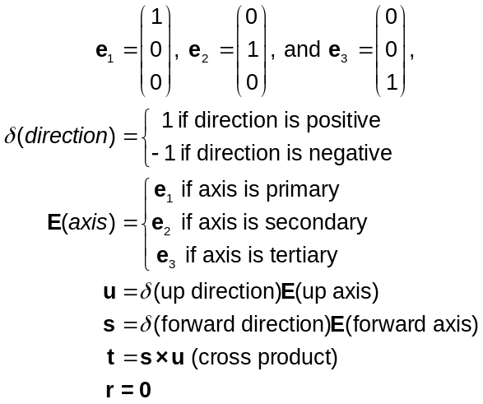
Coordinate valid region | No additional restrictions.
Notes | CAD/CAM and other engineering applications.
Reference type | IR
References | TBD

Local space rectangular 2D SRF
Local space rectangular 2D SRFs shall be derived from the SRFT specified in Table 8.6.
Table 8.6 — Local space rectangular 2D SRF template
Specification element | Value
Label | SRFT_2D_LOCAL_SPACE_RECTANGULAR
Code | 3
Description | Local space rectangular 2D SRF.
Object type | Abstract object.
ORM constraint | Shall be an ORM for a 2D abstract object.
CS label | CS_3D_LOCOCENTRIC_EUCLIDEAN
CS coordinate names and/or symbols | The same as the CS.
Template parameters | Primary axis (1, 2).  Direction of up (+1, -1).
CS parameter binding rules | 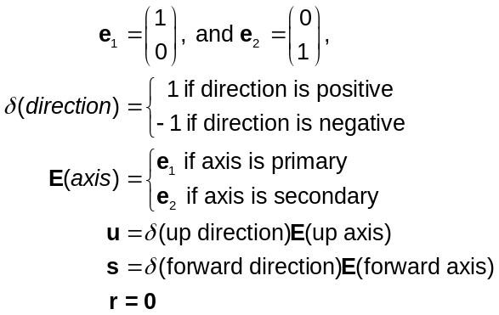
Coordinate valid region | No additional restrictions.
Notes | CAD/CAM and 2D graphic applications.
Reference type | IR
References | TBD

Celestiodetic SRF
Celestiodetic SRFs shall be derived from the SRFT specified in Table 8.7.
Table 8.7 — Celestiodetic SRFT
Specification element | Value
Label | SRFT_CELESTIODETIC
Code | 4
Description | Celestiodetic SRF.
Object type | Celestial object.
ORM constraint | Shall be derived from:  ORMT_3D_OBLATE_SPHEROID or  ORMT_3D_SPHERE
CS label | CS_3D_GEODETIC
CS coordinate names and/or symbols | The same as the CS.  Ellipsoidal height is the vertical coordinate.
Template parameters | None.
CS parameter binding rules | CS parameters equal RD values:  Oblate spheroid RD case -  Major semi-axis a, inverse flattening f ⁻¹  Sphere RD case -  Radius a
Coordinate valid region | No additional restrictions.
Notes | - The CS_S3_SURFACE_GEODETIC CS is induced on the oblate spheroid (or sphere) RD surface.  - When the object is Earth, this SRF is referred to as a geodetic SRF.
Reference type | IR
References | TBD

Local tangent plane 3D SRF
Local tangent plane 3D SRFs shall be derived from the SRFT specified in Table 8.8.
Table 8.8 — Local tangent plane 3D SRFT
Specification element |  | Value
Label |  | SRFT_3D_LOCAL_TANGENT_PLANE
Code |  | 5
Description |  | Local Tangent Plane 3D SRF.
Object type |  | Celestial object.
ORM constraint |  | Shall be derived from:  ORMT_3D_OBLATE_SPHEROID or  ORMT_3D_SPHERE
CS label |  | CS_3D_LOCOCENTRIC_EUCLIDEAN
CS coordinate names and/or symbols |  | u: x (x)  v: y (y)  w: height (h) is the vertical coordinate.
Template parameters |  | 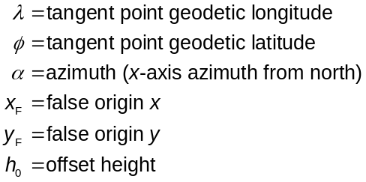
CS parameter binding rules |  | 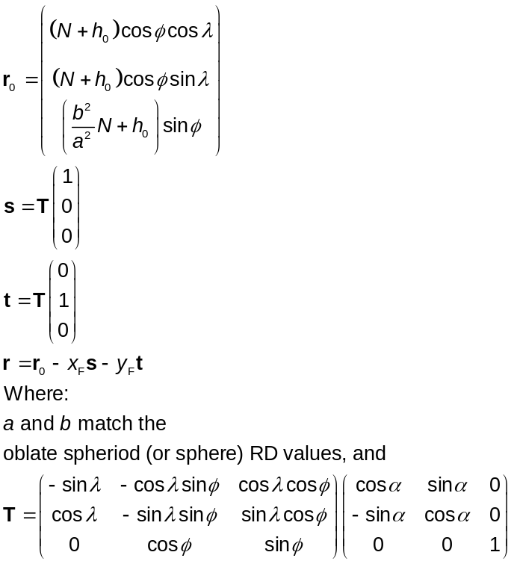
Coordinate valid region |  | No additional restrictions.
Notes |  | - The CS_S3_TOPOCENTRIC_SURFACE_EUCLIDEAN CS is induced on the tangent plane surface.  - Plane tangent to the oblate spheroid RD at surface celestiodetic coordinates (λ,φ). α is the azimuth of the x-axis.
Reference type | IR
References | TBD

[Editor’s Note: Add diagram that illustrates the relationship between the tangent plane surface and the RD.]

Local azimuthal spherical tangent plane SRF
Local azimuthal spherical tangent plane SRFs shall be derived from the SRFT specified in Table 8.9.
Table 8.9 — Local azimuthal spherical tangent plane SRFT
Specification element | Value
Label | SRFT_LOCAL_AZIMUTHAL_SPHERICAL_TANGENT_PLANE
Code | 6
Description | Local azimuthal spherical tangent plane SRF.
Object type | Celestial object.
ORM constraint | Shall be derived from:  ORMT_3D_OBLATE_SPHEROID or  ORMT_3D_SPHERE
CS label | CS_3D_LOCOCENTRIC_AZIMUTHAL_SPHERICAL
CS coordinate names and/or symbols | The same as the CS.
Template parameters | 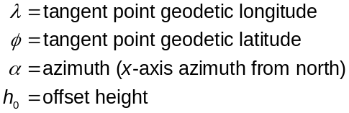
CS parameter binding rules | 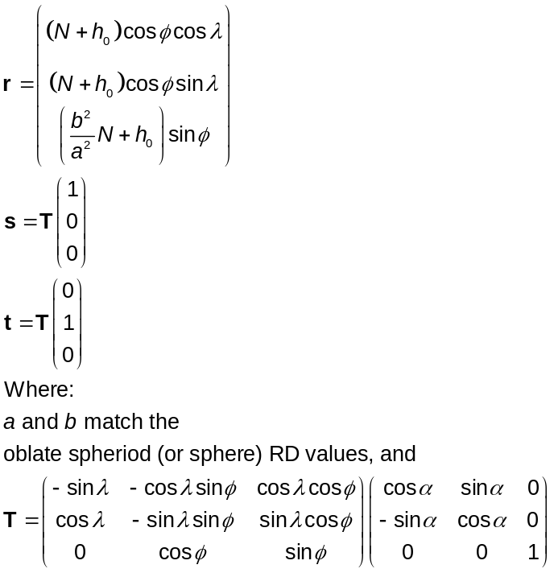
Coordinate valid region | No additional restrictions.
Notes | Used in radar localization.
Reference type | IR
References | TBD

Surface local azimuthal tangent plane SRF
Surface local azimuthal tangent plane SRFs shall be derived from the SRFT specified in Table 8.10.
Table 8.10 — Surface local azimuthal tangent plane SRFT
Specification element | Value
Label | SRFT_SURFACE_LOCAL_AZIMUTHAL_TANGENT_PLANE
Code | 7
Description | Surface local azimuthal tangent plane SRF.
Object type | Celestial object.
ORM constraint | Shall be derived from:  ORMT_3D_OBLATE_SPHEROID or  ORMT_3D_SPHERE
CS label | CS_S3_LOCOCENTRIC_SURFACE_AZIMUTHAL
CS coordinate names and/or symbols | The same as the CS.
Template parameters
CS parameter binding rules
Coordinate valid region | No additional restrictions.
Notes | Used in radar localization.
Reference type | IR
References | TBD

Azimuthal 2D SRF
Azimuthal 2D SRFs shall be derived from the SRFT specified in Table 8.11.
Table 8.11 — Azimuthal 2D SRFT
Specification element | Value
Label | SRFT_2D_AZIMUTHAL
Code | 8
Description | Azimuthal 2D SRF.
Object type | Abstract object.
ORM constraint | Shall be an ORM for a 2D abstract object.
CS label | CS_2D_AZIMUTHAL
CS coordinate names and/or symbols | The same as the CS.
Template parameters | None.
CS parameter binding rules | None.
Coordinate valid region | No additional restrictions.
Notes | None.
Reference type | IR
References | TBD

Local cylindrical tangent plane SRF
Local cylindrical tangent plane SRFs shall be derived from the SRFT specified in Table 8.12.
Table 8.12 — Local cylindrical tangent plane SRFT
Specification element | Value
Label | SRFT_LOCAL_CYLINDRICAL_TANGENT_PLANE
Code | 9
Description | Local cylindrical tangent plane SRF.
Object type | Celestial object.
ORM constraint | Shall be derived from:  ORMT_3D_OBLATE_SPHEROID or  ORMT_3D_SPHERE
CS label | CS_3D_LOCOCENTRIC_CYLINDRICAL
CS coordinate names and/or symbols | 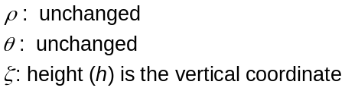
Template parameters
CS parameter binding rules
Coordinate valid region | No additional restrictions.
Notes | - The CS_S3_LOCOCENTRIC_SURFACE_POLAR CS is induced on the tangent plane surface.  - Plane tangent to the oblate spheroid (or sphere) RD at surface celestiodetic coordinates (λ,φ). α is the azimuth of the x-axis.
Reference type | IR
References | TBD

Polar 2D SRF
Polar 2D SRFs shall be derived from the SRFT specified in Table 8.13.
Table 8.13 — Polar 2D SRFT
Specification element | Value
Label | SRFT_2D_POLAR
Code | 10
Description | Polar 2D SRF.
Object type | Abstract object.
ORM constraint | Shall be an ORM for a 2D abstract object.
CS label | CS_2D_POLAR
CS coordinate names and/or symbols | The same as the CS.
Template parameters | None.
CS parameter binding rules | None.
Coordinate valid region | No additional restrictions.
Notes | None.
Reference type | IR
References | TBD

Celestiomagnetic SRF
Celestiomagnetic SRFs shall be derived from the SRFT specified in Table 8.14.
Table 8.14 — Celestiomagnetic SRFT
Specification element | Value
Label | SRFT_CELESTIOMAGNETIC
Code | 11
Description | Magnetic SRF.
Object type | Celestial object.
ORM constraint | Shall be an ORM from Table 7.17.
CS label | CS_3D_SPHERICAL
CS coordinate names and/or symbols | The same as the CS.
Template parameters | None.
CS parameter binding rules | None.
Coordinate valid region | No additional restrictions.
Notes | - See clause 7.5.7.  - When the object is Earth, this SRF is referred to as a geomagnetic SRF.
Reference type | IR
References | TBD

Equatorial inertial SRF
Equatorial inertial SRFs shall be derived from the SRFT specified in Table 8.15.
Table 8.15 — Equatorial inertial SRFT
Specification element | Value
Label | SRFT_EQUATORIAL_INERTIAL
Code | 12
Description | Equatorial Inertial SRF.
Object type | Planet.
ORM constraint | Shall be an ORM from Table 7.20.
CS label | CS_3D_SPHERICAL
CS coordinate names and/or symbols | λ : right ascension (ra)  θ : declination (dec)  ρ : radius (r)
Template parameters | None.
CS parameter binding rules | None.
Coordinate valid region | No additional restrictions.
Notes | See clause 7.5.2.
Reference type | IR
References | TBD

Solar ecliptic SRF
Solar ecliptic SRFs shall be derived from the SRFT specified in Table 8.16.
Table 8.16 — Solar ecliptic SRFT
Specification element | Value
Label | SRFT_SOLAR_ECLIPTIC
Code | 13
Description | Solar ecliptic SRF.
Object type | Planet.
ORM constraint | Shall be an ORM from Table 7.14.
CS label | CS_3D_SPHERICAL
CS coordinate names and/or symbols | The same as the CS.
Template parameters | None.
CS parameter binding rules | None.
Coordinate valid region | No additional restrictions.
Notes | See clause 7.5.3.
Reference type | IR
References | TBD

Solar equatorial SRF
Solar equatorial SRFs shall be derived from the SRFT specified in Table 8.17.
Table 8.17 — Solar equatorial SRFT
Specification element | Value
Label | SRFT_SOLAR_EQUATORIAL
Code | 14
Description | Solar equatorial SRF.
Object type | Planet.
ORM constraint | Shall be an ORM from Table 7.16.
CS label | CS_3D_SPHERICAL
CS coordinate names and/or symbols | The same as the CS.
Template parameters | None.
CS parameter binding rules | None.
Coordinate valid region | No additional restrictions.
Notes | See clause 7.5.4.
Reference type | IR
References | TBD

Solar magnetospheric SRF
Solar magnetospheric SRFs shall be derived from the SRFT specified in Table 8.18.
Table 8.18 — Solar magnetospheric SRFT
Specification element | Value
Label | SRFT_SOLAR_MAGNETOSPHERIC
Code | 15
Description | Solar magnetospheric SRF.
Object type | Planet.
ORM constraint | Shall be an ORM from Table 7.22.
CS label | CS_3D_SPHERICAL
CS coordinate names and/or symbols | The same as the CS.
Template parameters | None.
CS parameter binding rules | None.
Coordinate valid region | No additional restrictions.
Notes | See clause 7.5.8.
Reference type | IR
References | TBD

Solar magnetic SRF
Solar magnetic SRFs shall be derived from the SRFT specified in Table 8.19.
Table 8.19 — Solar magnetic SRFT
Specification element | Value
Label | SRFT_SOLAR_MAGNETIC
Code | 16
Description | Solar magnetic SRF.
Object type | Planet.
ORM constraint | Shall be an ORM from Table 7.24.
CS label | CS_3D_SPHERICAL
CS coordinate names and/or symbols | The same as the CS.
Template parameters | None.
CS parameter binding rules | None.
Coordinate valid region | No additional restrictions.
Notes | See clause 7.5.9.
Reference type | IR
References | TBD

Heliospheric Aries ecliptic SRF
Heliospheric Aries ecliptic SRFs shall be derived from the SRFT specified in Table 8.20.
Table 8.20 — Heliospheric Aries ecliptic SRFT
Specification element | Value
Label | SRFT_HELIOSPHERIC_ARIES_ECLIPTIC
Code | 17
Description | Heliospheric Aries ecliptic SRF.
Object type | Sun.
ORM constraint | Embedding origin is at solar mass centre.
CS label | CS_3D_SPHERICAL
CS coordinate names and/or symbols | The same as the CS.
Template parameters | None.
CS parameter binding rules | None.
Coordinate valid region | No additional restrictions.
Notes | See Clause TBD.
Reference type | IR
References | TBD

Heliospheric Earth ecliptic SRF
Heliospheric Earth ecliptic SRFs shall be derived from the SRFT specified in Table 8.21.
Table 8.21 — Heliospheric Earth ecliptic SRFT
Specification element | Value
Label | SRFT_HELIOSPHERIC_EARTH_ECLIPTIC
Code | 18
Description | Heliospheric Earth ecliptic SRF.
Object type | Sun.
ORM constraint | Embedding origin is at solar mass centre.
CS label | CS_3D_SPHERICAL
CS coordinate names and/or symbols | The same as the CS.
Template parameters | None.
CS parameter binding rules | None.
Coordinate valid region | No additional restrictions.
Notes | See clause 7.5.5.
Reference type | IR
References | TBD

Heliospheric Earth equatorial SRF
Heliospheric Earth equatorial SRFs shall be derived from the SRFT specified in Table 8.22.
Table 8.22 — Heliospheric Earth equatorial SRFT
Specification element | Value
Label | SRFT_HELIOSPHERIC_EARTH_EQUATORIAL
Code | 19
Description | Heliospheric Earth equatorial SRF.
Object type | Sun.
ORM constraint | Embedding origin is at solar mass centre.
CS label | CS_3D_SPHERICAL
CS coordinate names and/or symbols | The same as the CS.
Template parameters | None.
CS parameter binding rules | None.
Coordinate valid region | No additional restrictions.
Notes | See clause 7.5.6.
Reference type | IR
References | TBD

Mercator SRF
Mercator SRFs shall be derived from the SRFT specified in Table 8.23.
Table 8.23 — Mercator SRFT
Specification element | Value
Label | SRFT_MERCATOR
Code | 20
Description | Mercator SRF.
Object type | Celestial object.
ORM constraint | Shall be derived from:  ORMT_3D_OBLATE_SPHEROID or  ORMT_3D_SPHERE
CS label | CS_MP_MERCATOR
CS coordinate names and/or symbols | Same as the CS.  h: ellipsoidal height is the vertical coordinate.
Template parameters | 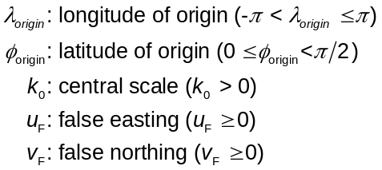
CS parameter binding rules | CS parameters match RD values:  Oblate spheroid RD case -  Major semi-axis a, 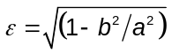  Sphere RD case -  Radius a, 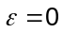
Coordinate valid region | No additional restrictions.
Notes | The augmented Mercator CS induces the Mercator CS on the zero value vertical coordinate surface (which coincides with the RD surface).
Reference type | IR
References | TBD

Oblique Mercator SRF
Oblique Mercator SRFs shall be derived from the SRFT specified in Table 8.24.
Table 8.24 — Oblique Mercator SRFT
Specification element | Value
Label | SRFT_OBLIQUE_MERCATOR
Code | 21
Description | Oblique Mercator SRF.
Object type | Celestial object.
ORM constraint | Shall be derived from ORMT_3D_SPHERE.
CS label | CS_MP_OBLIQUE_MERCATOR
CS coordinate names and/or symbols | Same as the CS.  h: ellipsoidal height is the vertical coordinate.
Template parameters | 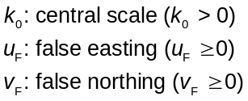
CS parameter binding rules | CS parameters match RD values:  Radius a
Coordinate valid region | No additional restrictions.
Notes | The augmented oblique Mercator CS induces the oblique Mercator CS on the zero value vertical coordinate surface (which coincides with the RD surface).
Reference type | IR
References | TBD

Transverse Mercator SRF
Transverse Mercator SRFs shall be derived from the SRFT specified in Table 8.25.
Table 8.25 — Transverse Mercator SRFT
Specification element | Value
Label | SRFT_TRANSVERSE_MERCATOR
Code | 22
Description | Transverse Mercator SRF.
Object type | Celestial object.
ORM constraint | Shall be derived from:  ORMT_3D_OBLATE_SPHEROID or  ORMT_3D_SPHERE
CS label | CS_MP_TRANSVERSE_MERCATOR
CS coordinate names and/or symbols | Same as the CS.  h: ellipsoidal height is the vertical coordinate.
Template parameters | 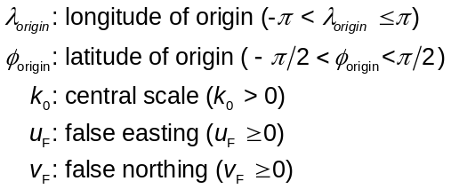
CS parameter binding rules | CS parameters match RD values:  Oblate spheroid RD case -  Major semi-axis a,  Sphere RD case -  Radius a,
Coordinate valid region | No additional restrictions.
Notes | The augmented transverse Mercator CS induces the transverse Mercator CS on the zero value vertical coordinate surface (which coincides with the RD surface).
Reference type | IR
References | TBD

Lambert conformal conic SRF
Lambert conformal conic SRFs shall be derived from the SRFT specified in Table 8.26.
Table 8.26 — Lambert conformal conic SRFT
Specification element | Value
Label | SRFT_LAMBERT_CONFORMAL_CONIC
Code | 23
Description | Lambert conformal conic SRF.
Object type | Celestial object.
ORM constraint | Shall be derived from:  ORMT_3D_OBLATE_SPHEROID or  ORMT_3D_SPHERE
CS label | CS_MP_LAMBERT_CONFORMAL_CONIC
CS coordinate names and/or symbols | Same as the CS.  h: ellipsoidal height is the vertical coordinate.
Template parameters | 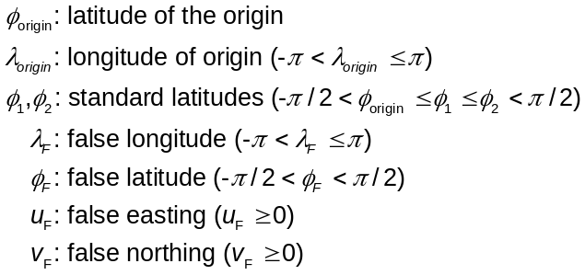
CS parameter binding rules | CS parameters match RD values:  Oblate spheroid RD case -  Major semi-axis a,  Sphere RD case -  Radius a,
Coordinate valid region | No additional restrictions.
Notes | The augmented Lambert conformal conic CS induces the Lambert conformal conic CS on the zero value vertical coordinate surface (which coincides with the RD surface).
Reference type | IR
References | TBD

Polar stereographic SRF
Polar stereographic SRFs shall be derived from the SRFT specified in Table 8.27.
Table 8.27 — Polar stereographic SRFT
Specification element | Value
Label | SRFT_POLAR_STEREOGRAPHIC
Code | 24
Description | Polar stereographic SRF.
Object type | Celestial object.
ORM constraint | Shall be derived from:  ORMT_3D_OBLATE_SPHEROID or  ORMT_3D_SPHERE
CS label | CS_MP_POLAR_STEREOGRAPHIC
CS coordinate names and/or symbols | Same as the CS.  h: ellipsoidal height is the vertical coordinate.
Template parameters | 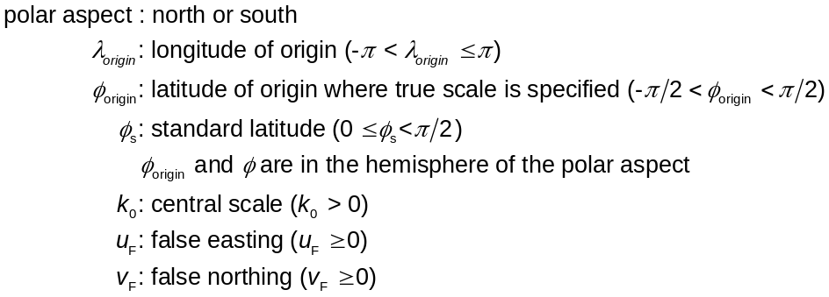
CS parameter binding rules | CS parameters match RD values:  Oblate spheroid RD case -  Major semi-axis a,  Sphere RD case -  Radius a,
Coordinate valid region | No additional restrictions.
Notes | The augmented polar stereographic CS induces the polar stereographic CS on the zero value vertical coordinate surface (which coincides with the RD surface).
Reference type | IR
References | TBD

Equidistant cylindrical SRF
Equidistant cylindrical SRFs shall be derived from the SRFT specified in Table 8.28.
Table 8.28 — Equidistant cylindrical SRFT
Specification element | Value
Label | SRFT_EQUIDISTANT_CYLINDRICAL
Code | 25
Description | Equidistant cylindrical SRF.
Object type | Celestial object.
ORM constraint | Shall be derived from ORMT_3D_SPHERE.
CS label | CS_MP_EQUIDISTANT_CYLINDRICAL
CS coordinate names and/or symbols | Same as the CS.  h: ellipsoidal height is the vertical coordinate.
Template parameters | 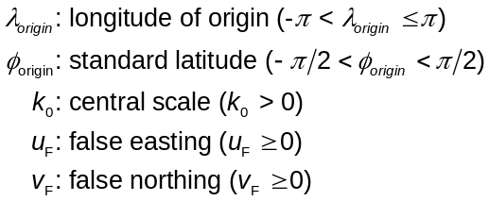
CS parameter binding rules | CS parameters match RD values:  Radius a,
Coordinate valid region | No additional restrictions.
Notes | The augmented equidistant cylindrical CS induces the equidistant cylindrical CS on the zero value vertical coordinate surface (which coincides with the RD surface).
Reference type | IR
References | TBD

SRFs
This International Standard specifies a collection of SRFs. These specifications appear in Table 8.30. These SRFs are each derived from a SRFT. Additional SRFs derived from SRFTs may be registered in accordance with Clause 12.
The specification elements for SRFTs are defined in Table 8.29.
Table 8.29 — SRF specification elements
Specification element | Definition
Label | The label (see 12.2.2).
Code | The code (see 12.2.3).
Description | A description including name as published or as commonly known.
SRFT | The label of the applicable SRF template.
ORM | The label of the applicable ORM.
Region | Optional restriction of the domain of the CS to a valid region. If a valid region is specified, optionally an extended valid region. If both are unspecified, then there are no additional constraints on coordinate validity.
Parameter values | The SRF template parameter values
Notes | Optional, additional, non-normative information concerning the SRF, such as description of its structure, modelled region, intended use, and/or application domain.
Reference type | The reference type (see 12.2.5).
References | The references (see 12.2.5).

Table 8.30 — SRFs
Label | SRF_BRITISH_NATIONAL_GRID | Code | 1
Description | British National Grid
SRF template | SRFT_TRANSVERSE_MERCATOR | ORM | ORM_OSGB_1936_MEAN_SOLUTION
Region | Valid region description:  Great Britain.
Parameter values | Central meridian: λ₀ = -2º  Scale on central meridian: k₀ = 0,999 601 271 7  True origin: (49ºN, 2ºW).  False easting: u_{F} = -400 000 m.  False northing: v_{F} = 100 000 m.
Notes | None.
Reference type | IR | References | [OSTM]
Label | SRF_DELAWARE_SPCS | Code | 2
Description | Delaware (US) State Plane Coordinate System
SRF template | SRFT_TRANSVERSE_MERCATOR | ORM | ORM_N_AM_1983_CONUS
Region | Valid region description:  State of Delaware (US).
Parameter values | Central meridian: λ₀ = -75º 25′  Scale on central meridian: k₀ = (1 - 1/200 000)  True origin: (38ºN, 75º 25′W)  False easting: u_{F} = 200 000 m.  False northing: v_{F} = 0 m.
Notes | To convert coordinates in metres to grid coordinates in US survey feet, use 1 m. = (39,37 / 12) US survey feet.
Reference type | IR | References | [SNYD, Appendix C]
Label | SRF_GEOCENTRIC_EARTH_1984 | Code | 3
Description | Geocentric WGS 1984
SRF template | SRFT_CELESTIOCENTRIC | ORM | ORM_WGS_1984
Region | Valid region description:  Global Earth.
Parameter values | None.
Notes | Mass centred.
Reference type | IR | References | [83502T, Chapter 2.1]
Label | SRF_GEODETIC_AUSTRALIA-  _1984 | Code | 4
Description | Geodetic Australia 1984
SRF template | SRFT_CELESTIODETIC | ORM | ORM_AUSTRALIAN_GEOD_1984_7
Region | Valid region description:  Australia and Tasmania.
Parameter values | None.
Notes | None.
Reference type | IR | References | [CECT]
Label | SRF_GEODETIC_AUSTRALIA-  _1990 | Code | 5
Description | Geodetic Australia 1990
SRF template | SRFT_CELESTIODETIC | ORM | ORM_GEOCENTRIC_DATUM_AUSTRALIA
Region | Valid region description:  Australia.
Parameter values | None.
Notes | None.
Reference type | IR | References | [CECT]
Label | SRF_GEODETIC_EARTH_1984 | Code | 6
Description | Geodetic WGS 1984
SRF template | SRFT_CELESTIODETIC | ORM | ORM_WGS_1984
Region | Valid region description:  Global Earth.
Parameter values | None.
Notes | None.
Reference type | IR | References | [83502T, Chapter 3]
Label | SRF_GEODETIC_EUROPE_1950 | Code | 7
Description | Geodetic Europe 1950
SRF template | SRFT_CELESTIODETIC | ORM | ORM_EUR_1950_MEAN_SOLUTION
Region | Valid region description:  Europe.
Parameter values | None.
Notes | None.
Reference type | IR | References | [83502T, App. B.5, "EUR-M"], [HELM, "EUR-M"]
Label | SRF_GEODETIC_JAPAN_1991 | Code | 8
Description | Geodetic Japan 1991
SRF template | SRFT_CELESTIODETIC | ORM | ORM_TOKYO_MEAN_SOLUTION
Region | Valid region description:  Japan, Korea, and Okinawa.
Parameter values | None.
Notes | None.
Reference type | IR | References | [83502T, App. B.3, "TOY-M"]
Label | SRF_GEODETIC_N_AMERICAN-_1950 | Code | 9
Description | Geodetic North American 1983
SRF template | SRFT_CELESTIODETIC | ORM | ORM_N_AM_1983_CONUS
Region | Valid region description:  Continental United States.
Parameter values | None.
Notes | None.
Reference type | IR | References | [SNYD]
Label | SRF_IRISH_GRID | Code | 10
Description | Irish Grid
SRF template | SRFT_TRANSVERSE_MERCATOR | ORM | ORM_IRELAND_1965
Region | Valid region description:  Ireland.
Parameter values | Central meridian: λ₀ = -8º  Scale on central meridian: k₀ = 1,000 035  True origin: (53º 30′N, 8ºW)  False easting: u_{F} = 200 000 m.  False northing: v_{F} = 250 000 m.
Notes | None.
Reference type | IR | References | [IGRID]
Label | SRF_IRISH_TRANSVERSE-  _MERCATOR | Code | 11
Description | Irish Transverse Mercator
SRF template | SRFT_TRANSVERSE_MERCATOR | ORM | ORM_ETRS_1989
Region | Valid region description:  Ireland.
Parameter values | Central meridian: λ₀ = -8º  Scale on central meridian: k₀ = 0,999 820  True origin: (53º 30′N, 8ºW)  False easting: u_{F} = 600 000 m.  False northing: v_{F} = 750 000 m.
Notes | None.
Reference type | IR | References | [NMPI]
Label | SRF_LAMBERT_93 | Code | 12
Description | Lambert-93
SRF template | SRFT_LAMBERT_CONFORMAL_CONIC | ORM | ORM_RGF_1993
Region | Valid region description:  France.
Parameter values | First parallel: φ₁ = 44º  Second parallel: φ₂ = 49º  True origin: (46º 30′N, 3ºE)  False easting: u_{F} = 700 000 m.  False northing: v_{F} = 6 600 000 m.
Notes | None.
Reference type | IR | References | [PASG]
Label | SRF_LAMBERT_II_WIDE | Code | 13
Description | Lambert II étendu (Lambert II wide)
SRF template | SRFT_LAMBERT_CONFORMAL_CONIC | ORM | ORM_NEW_FRENCH_ZERO
Region | Valid region description:  France.
Parameter values | First parallel: φ₁ = 45º 53′ 56,108″  Second parallel: φ₂ = 47º 41′ 45,652″  True origin: (46º 48′N, 0ºE)  False easting: u_{F} = 600 000 m.  False northing: v_{F} = 2 200 000 m.
Notes | None.
Reference type | IR | References | [LIIE]
Label | SRF_MARYLAND_SPCS | Code | 14
Description | Maryland (US) State Plane Coordinate System
SRF template | SRFT_LAMBERT_CONFORMAL_CONIC | ORM | ORM_N_AM_1983_CONUS
Region | Valid region description:  State of Maryland (US).
Parameter values | First parallel: φ₁ = 38º 18′  Second parallel: φ₂ = 39º 27′  True origin: (37º 50′N, 77ºW)  False easting: u_{F} = 400 000 m.  False northing: v_{F} = 0 m.
Notes | To convert coordinates in metres to grid coordinates in US survey feet, use 1 m. = (39,37 / 12) US survey feet.
Reference type | IR | References | [SNYD, Appendix C]

SRF sets
Given an ORM, an SRF set is a finite parameterized set of two or more SRFs that:
- are derived from the same SRF template using the given ORM, and
- the valid regions of the set members are non-overlapping.
An SRF set specification may further restrict the ORM constraints of the SRFT. The specification elements for SRF sets are defined in Table 8.31.
Table 8.31 — SRF set specification elements
Specification element | Definition
Label | The label (see 12.2.2).
Code | The code (see 12.2.3).
Description | A description including name as published or as commonly known.
SRFT | The label of the applicable SRFT.
ORM constraints | Criteria for allowable ORMs. Specifying a single ORM indicates that only that ORM shall be used.
Region | Optional restriction of the domain of the SRF set to a valid region. If a valid region is specified, optionally an extended valid region. If both are unspecified, then there are no additional constraints on coordinate validity.
SRF set  membership | A specification of the parameterization of the set members, by listing or parameter algorithm.
Notes | A description of the structure, modelled region, intended use, and/or application domain of the SRF set.
Reference type | The reference type (see 12.2.5).
References | The reference type (see 12.2.5).

This International Standard specifies a collection of SRF sets. These specifications appear in Table 8.32. Additional SRF sets may be registered in accordance with Clause 12.
Table 8.32 — SRF sets
Label | SRFS_ALABAMA_SPCS | Code | 1
Description | Alabama (US) State Plane Coordinate System.
SRF template | SRFT_TRANSVERSE_MERCATOR | ORM constraints | ORM_N_AM_1983_CONUS
Region | Valid region description:  State of Alabama (US).
SRF set membership | Table 8.34, subheading SRFS_ALABAMA_SPCS.
Notes | A set of two localized adjacent SRFs where only one SRF is used for each county in the state and no overlap is allowed.
Reference type | IR | References | [SNYD, Appendix C]
Label | SRFS_GTRS_GLOBAL-_COORDINATE_SYSTEM | Code | 2
Description | GTRS global coordinate system (Earth).
SRF template | SRFT_3D_LOCAL_TANGENT_PLANE | ORM constraints | A global model ERM such as ORM_WGS_1984.
Region | Valid region description:  Earth (complete).
SRF set membership | Table 8.35, subheading SRFS_GTRS_GLOBAL_COORDINATE_SYSTEM.
Notes | A set of 49 896 localized (but overlapping) SRFs, each approximately 100 kilometres square, that are identified according to the geotile reference system indexing scheme.  The commonly known GCS SRF set specifies the ORM_WGS_1984 as the ERM. The members of this SRF set are commonly known as cells. For much of the RD surface, each cell valid region covers one arc degree of geodetic latitude by one arc degree of geodetic longitude. However, near the poles, many arc degrees of longitude are grouped together into a single GCS cell since an arc degree of geodetic longitude becomes arbitrarily small near the poles. GCS cells are always one arc degree of geodetic latitude in extent. Within each GCS cell, a false origin offset is provided. The point of tangency is at the centre of the rectangular GCS cell, even if more than one arc degree of geodetic longitude falls within a GCS SRF cell. The SRFT_3D_LOCAL_TANGENT_PLANE azimuth parameter (α) is zero.
Reference type | IR | References | TBS
Label | SRFS_LAMBERT_NTF | Code | 3
Description | Lambert projection-based mapping system for France associated with the NTF.
SRF template | SRFT_LAMBERT_CONFORMAL_CONIC | ORM constraints | ORM_NEW_FRENCH_ZERO
Region | Valid region description:  France.
SRF set membership | Table 8.34, subheading SRFS_LAMBERT_NTF.
Notes | A set of four localized adjacent SRFs where only one SRF is used for each portion of France and no overlap is allowed.
Reference type | IR | References | [LIIE]
Label | SRFS_MARS_TRANSVERSE_MERCATOR-_BODY | Code | 4
Description | Mars Transverse Mercator (MTM) map series system, body (non-polar) regions.
SRF template | SRFT_TRANSVERSE_MERCATOR | ORM constraints | ORM_MARS
Region | Valid region specification:  -82,5º ≤ latitude ≤ 82,5º
SRF set membership | Table 8.35, subheading SRFS_MARS_TRANSVERSE_MERCATOR_BODY.
Notes | A set of 1 944 localized (but overlapping) SRFs that are used to index 1:500 000 scale geologic and photomosaic maps of Mars non-polar regions. Uses planetocentric, rather than planetographic, referencing and shares a common boundary with SRFS_MARS_TRANSVERSE_MERCATOR_POLE.
Reference type | IR | References | [MTMM]
Label | SRFS_MARS_TRANSVERSE_MERCATOR_POLE | Code | 5
Description | Mars Transverse Mercator (MTM) map series system, polar regions.
SRF template | SRFT_POLAR_STEREOGRAPHIC | ORM constraints | ORM_MARS
Region | Valid region specification:  latitude < -82,5º or 82,5º ≤ latitude
SRF set membership | Table 8.35, subheading SRFS_MARS_TRANSVERSE_MERCATOR_POLE.
Notes | A set of 20 localized (but overlapping) SRFs that are used to index 1:500 000 scale geologic and photomosaic maps of Mars polar regions. Uses planetocentric, rather than planetographic, referencing and shares a common boundary with SRFS_MARS_TRANSVERSE_MERCATOR_BODY.
Reference type | IR | References | [MTMM]
Label | SRFS_UNIVERSAL_POLAR_STEREOGRAPHIC | Code | 6
Description | Universal Polar Stereographic (Earth).
SRF template | SRFT_POLAR_STEREOGRAPHIC | ORM constraints | A global model ERM such as ORM_WGS_1984.
Region | Valid region specification:  latitude < -80º or 84º ≤ latitude  Extended valid region specification:  latitude < -79,5º or 83,5º ≤ latitude
SRF set membership | Table 8.35, subheading SRFS_UNIVERSAL_POLAR_STEREOGRAPHIC.
Notes | A set of two localized adjacent SRFs, where limited overlap is modelled by extended validity of coordinates in the member SRFs. Shares a common boundary with SRFS_UNIVERSAL_TRANSVERSE_MERCATOR.
Reference type | IR | References | [83582]
Label | SRFS_UNIVERSAL_TRANSVERSE_MERCATOR | Code | 7
Description | Universal Transverse Mercator (Earth).
SRF template | SRFT_TRANSVERSE_MERCATOR | ORM constraints | A global model ERM such as ORM_WGS_1984.
Region | Valid region specification:  -80º ≤ latitude ≤ 84º  Extended valid region specification:  -80,5º < latitude ≤ 84,5º
SRF set membership | Table 8.35, subheading SRFS_UNIVERSAL_TRANSVERSE_MERCATOR.
Notes | A set of 120 localized SRFs, where limited overlap is modelled by extended validity of coordinates in the member SRFs. Shares a common boundary with SRFS_UNIVERSAL_POLAR_STEREOGRAPHIC.
Reference type | IR | References | [83582]
Label | SRFS_WISCONSIN_SPCS | Code | 8
Description | Wisconsin (US) State Plane Coordinate System.
SRF template | SRFT_LAMBERT_CONFORMAL_CONIC | ORM constraints | ORM_N_AM_1983_CONUS
Region | Valid region description:  State of Wisconsin (US).
SRF set membership | Table 8.34, subheading SRFS_WISCONSIN_SPCS.
Notes | A set of three localized adjacent SRFs where only one SRF is used for each county in the state and no overlap is allowed.
Reference type | IR | References | [WSCO]

The specification elements for SRF set members are defined in Table 8.33.
Table 8.33 — SRF set member specification elements
Specification element | Definition | Location
SRF set label | The label of the SRF set (see 12.2.2). | Table 8.34 or Table 8.35
Label | The label (see 12.2.2). | Table 8.34 or Table 8.35
Code | The code (see 12.2.3); the set member parameter. | Table 8.34 or Table 8.35
Description | A description including name as published or as commonly known. | Table 8.34 or Table 8.35
Region | A valid region description. Optionally an extended valid region description. | Table 8.34 or Table 8.35
Parameter values | The SRFT parameter values. | Table 8.34 or Table 8.35
Notes | Optional, additional, non-normative information concerning the SRF set member. | Table 8.34 or Table 8.35

This International Standard specifies a collection of SRF sets. These specifications appear in Table 8.34 and Table 8.35. Additional SRF set members may be registered in accordance with Clause 12.
Table 8.34 — Explicit specifications of SRF set members
SRFS_ALABAMA_SPCS
Label | WEST_ZONE | Code | 1
Description | West zone.
Region | Valid region description:  Alabama (US) counties of TBD.
Parameter values | Central meridian: λ₀ = -87º 30′  Scale on central meridian: k₀ = (1 - 1/15 000)  True origin: (30ºN, 87º 30′W)  False easting: u_{F} = 600 000 m.  False northing: v_{F} = 0 m.
Notes | To convert coordinates in metres to grid coordinates in US survey feet, use 1 m. = (39,37 / 12) US survey feet.
Label | EAST_ZONE | Code | 2
Description | East zone.
Region | Valid region description:  Alabama (US) counties of TBD.
Parameter values | Central meridian: λ₀ = -85º 50′  Scale on central meridian: k₀ = (1 - 1/25 000)  True origin: (30º&nbsp30′N, 85º 50′W)  False easting: u_{F} = 200 000 m.  False northing: v_{F} = 0 m.
Notes | To convert coordinates in metres to grid coordinates in US survey feet, use 1 m. = (39,37 / 12) US survey feet.
SRFS_LAMBERT_NTF
Label | ZONE_I | Code | 1
Description | Zone I.
Region | Valid region specification:  -5º ≤ λ ≤ 10º  -53,5º ≤ φ < 57º
Parameter values | First parallel: φ₁ = 48º 35′ 54,682″  Second parallel: φ₂ = 50º 23′ 45,282″  True origin: (49,5ºN, 0ºE)  False easting: u_{F} = 600 000 m.  False northing: v_{F} = 200 000 m.
Notes | None.
Label | ZONE_II | Code | 2
Description | Zone II.
Region | Valid region specification:  -5º ≤ λ ≤ 10º  -50,5º ≤ φ < 53,5º
Parameter values | First parallel: φ₁ = 45º 53′ 56,108″  Second parallel: φ₂ = 47º 41′ 45,652″  True origin: (46,8ºN, 0ºE)  False easting: u_{F} = 600 000 m.  False northing: v_{F} = 200 000 m.
Notes | None.
Label | ZONE_III | Code | 3
Description | Zone III.
Region | Valid region specification:  -5º ≤ λ ≤ 10º  -47º ≤ φ < 50,5º
Parameter values | First parallel: φ₁ = 43º 11′ 57,449″  Second parallel: φ₂ = 44º 59′ 45,938″  True origin: (44,1ºN, 0ºE)  False easting: u_{F} = 600 000 m.  False northing: v_{F} = 200 000 m.
Notes | None.
Label | ZONE_IV | Code | 4
Description | Zone IV.
Region | Valid region specification:  The island of Corsica.
Parameter values | First parallel: φ₁ = 41º 33′ 37,396″  Second parallel: φ₂ = 42º 46′ 3,588″  True origin: (42º 9′ 54″N, 0ºE)  False easting: u_{F} = 234 358 m.  False northing: v_{F} = 185 861,369 m.
Notes | None.
SRFS_WISCONSIN_SPCS
Label | SOUTH_ZONE | Code | 1
Description | South zone.
Region | Valid region description:  Wisconsin (US) counties of TBD.
Parameter values | First parallel: φ₁ = 42º 44′  Second parallel: φ₂ = 44º 04′  True origin: (42ºN, 90ºW)  False easting: u_{F} = 600 000 m.  False northing: v_{F} = 0 m.
Notes | To convert coordinates in metres to grid coordinates in US survey feet, use 1 m. = (39,37 / 12) US survey feet.
Label | CENTRAL_ZONE | Code | 2
Description | Central zone.
Region | Valid region description:  Wisconsin (US) counties of TBD.
Parameter values | First parallel: φ₁ = 44º 15′  Second parallel: φ₂ = 45º 30′  True origin: (43º 50′N, 90ºW)  False easting: u_{F} = 600 000 m.  False northing: v_{F} = 0 m.
Notes | To convert coordinates in metres to grid coordinates in US survey feet, use 1 m. = (39,37 / 12) US survey feet.
Label | NORTH_ZONE | Code | 3
Description | North zone.
Region | Valid region description:  Wisconsin (US) counties of TBD.
Parameter values | First parallel: φ₁ = 45º 34′  Second parallel: φ₂ = 46º 46′  True origin: (45º 10′N, 90ºW)  False easting: u_{F} = 600 000 m.  False northing: v_{F} = 0 m.
Notes | To convert coordinates in metres to grid coordinates in US survey feet, use 1 m. = (39,37 / 12) US survey feet.

Table 8.35 — Implicit specifications of SRF set members
SRFS_GTRS_GLOBAL_COORDINATE_SYSTEM
Label | “TILE_” + <code> | Code | 1…49 896: As specified in Table 8.37 through Table 8.51.
Description | Tile <code>.
Region | Valid region specification:  As specified in Table 8.36.  Extended valid region specification:  Unrestricted.
Parameter values | True origin: As specified in Table 8.37 through Table 8.51.  Azimuth: 0 rad.  False easting: u_{F} = -50 000 m.  False northing: v_{F} = -50 000 m.
Notes | None.
SRFS_MARS_TRANSVERSE_MERCATOR_BODY
Label | As specified in Table 8.52 and Table 8.53. |  |  | Code | 1… 1 944
Description | Region map designator.
Region | Valid region specification:  As specified in Table 8.52 and Table 8.53.
Parameter values | As specified in Table 8.52 and Table 8.53.
Notes | None.
SRFS_MARS_TRANSVERSE_MERCATOR_POLE
Label | As specified in Table 8.54 and Table 8.55. |  |  | Code | 1…20
Description | Region map designator.
Region | Valid region specification:  As specified in Table 8.54 and Table 8.55.
Parameter values | As specified in Table 8.54 and Table 8.55.
Notes | None.
SRFS_UNIVERSAL_POLAR_STEREOGRAPHIC
Label | As specified in Table 8.56 and Table 8.57. |  |  |  |  | Code | 1…2
Description | Northern or southern pole.
Region | Valid region specification:  As specified in Table 8.56 and Table 8.57.  Extended valid region specification:  As specified in Table 8.56 and Table 8.57.
Parameter values | Scale on central meridian: k₀ = 0,994  True origin: As specified in Table 8.56 and Table 8.57.  False easting: u_{F} = 2 000 000 m.  False northing: v_{F} = 2 000 000 m.
Notes | None.
SRFS_UNIVERSAL_TRANSVERSE_MERCATOR
Label | As specified in Table 8.58 and Table 8.59. |  |  |  |  | Code | 1…120
Description | UTM zone in northern or southern hemisphere.
Region | Valid region specification:  As specified in Table 8.58 and Table 8.59.  Extended valid region specification:  As specified in Table 8.58 and Table 8.59.
Parameter values | Central meridian: As specified in Table 8.58 and Table 8.59.  Scale on central meridian: k₀ = 0,999 6  True origin: As specified in Table 8.58 and Table 8.59.  False easting: u_{F} = 500 000 m.  False northing: As specified in Table 8.58 and Table 8.59.
Notes | None.

Table 8.36 — GTRS indexing scheme and set members directory
Band | Tile size | Valid range from true origin | Table number
88º-90ºN | 1º x 30º | ±0,5º latitude, ±15º longitude | Table 8.37
86º-88ºN | 1º x 15º | ±0,5º latitude, ±7,5º longitude | Table 8.38
84º-86ºN | 1º x 10º | ±0,5º latitude, ±5º longitude | Table 8.39
80º-84ºN | 1º x 6º | ±0,5º latitude, ±3º longitude | Table 8.40
78º-80ºN | 1º x 5º | ±0,5º latitude, ±2,5º longitude | Table 8.41
71º-78ºN | 1º x 3º | ±0,5º latitude, ±1,5º longitude | Table 8.42
60º-71ºN | 1º x 2º | ±0,5º latitude, ±1º longitude | Table 8.43
60ºS - 60ºN | 1º x 1º | ±0,5º latitude, ±0,5º longitude | Table 8.44
71º-60ºS | 1º x 2º | ±0,5º latitude, ±1º longitude | Table 8.45
78º-71ºS | 1º x 3º | ±0,5º latitude, ±1,5º longitude | Table 8.46
80º-78ºS | 1º x 5º | ±0,5º latitude, ±2,5º longitude | Table 8.47
84º-80ºS | 1º x 6º | ±0,5º latitude, ±3º longitude | Table 8.48
86º-84ºS | 1º x 10º | ±0,5º latitude, ±5º longitude | Table 8.49
88º-86ºS | 1º x 15º | ±0,5º latitude, ±7,5º longitude | Table 8.50
90º-88ºS | 1º x 30º | ±0,5º latitude, ±15º longitude | Table 8.51

[Editor’s Note: Each of the following GTRS tables should be accompanied by a (non-normative) NOTE expressing the relationship between code and true origin in terms of a formula.]
Table 8.37 — GTRS indexing scheme and set members: 88º-90º north
First cell in row | Other cells in row | Last cell in row
Code True origin | Code True origin | Code True origin
49885 (89,5º, -165º) | 49886…49895 (89,5º, -165º +[1…10]•30º) | 49896 (89,5º, 165º)
49873 (88,5º, -165º) | 49874…49883 (88,5º, -165º +[1…10]•30º) | 49884 (88,5º, 165º)

Table 8.38 — GTRS indexing scheme and set members: 86º-88º north
First cell in row | Other cells in row | Last cell in row
Code True origin | Code True origin | Code True origin
49849 (87,5º, -172,5º) | 49850…49871 (87,5º, -172,5º +[1…22]•15º) | 49872 (87,5º, 172,5º)
49825 (86,5º, -172,5º) | 49826…49847 (86,5º, -172,5º +[1…22]•15º) | 49848 (86,5º, 172,5º)

Table 8.39 — GTRS indexing scheme and set members: 84º-86º north
First cell in row | Other cells in row | Last cell in row
Code True origin | Code True origin | Code True origin
49789 (85,5º, -175º) | 49790…49823 (85,5º, -175º +[1…34]•10º) | 49824 (85,5º, 175º)
49753 (84,5º, -175º) | 49754…49787 (84,5º, -175º +[1…34]•10º) | 49788 (84,5º, 175º)

Table 8.40 — GTRS indexing scheme and set members: 80º-84º north
First cell in row | Other cells in row | Last cell in row
Code True origin | Code True origin | Code True origin
49693 (83,5º, -177º) | 49694…49751 (83,5º, -177º +[1…58]•6º) | 49752 (83,5º, 177º)
49633 (82,5º, -177º) | 49634…49691 (82,5º, -177º +[1…58]•6º) | 49692 (82,5º, 177º)
49573 (81,5º, -177º) | 49574…49631 (81,5º, -177º +[1…58]•6º) | 49632 (81,5º, 177º)
49513 (80,5º, -177º) | 49514…49571 (80,5º, -177º +[1…58]•6º) | 49572 (80,5º, 177º)

Table 8.41 — GTRS indexing scheme and set members: 78º-80º north
First cell in row | Other cells in row | Last cell in row
Code True origin | Code True origin | Code True origin
49441 (79,5º, -177,5º) | 49442…49511 (79,5º, -177,5º +[1…70]•5º) | 49512 (79,5º, 177,5º)
49369 (78,5º, -177,5º) | 49370…49439 (78,5º, -177,5º +[1…70]•5º) | 49440 (78,5º, 177,5º)

Table 8.42 — GTRS indexing scheme and set members: 71º-78º north
First cell in row | Other cells in row | Last cell in row
Code True origin | Code True origin | Code True origin
49249 (77,5º, -178,5º) | 49250…49367 (77,5º, -178,5º +[1…118]•3º) | 49368 (77,5º, 178,5º)
49129 (76,5º, -178,5º) | 49130…49247 (76,5º, -178,5º +[1…118]•3º) | 49248 (76,5º, 178,5º)
49009 (75,5º, -178,5º) | 49010…49127 (75,5º, -178,5º +[1…118]•3º) | 49128 (75,5º, 178,5º)
48889 (74,5º, -178,5º) | 48890…49007 (74,5º, -178,5º +[1…118]•3º) | 49008 (74,5º, 178,5º)
48769 (73,5º, -178,5º) | 48770…48887 (73,5º, -178,5º +[1…118]•3º) | 48888 (73,5º, 178,5º)
48649 (72,5º, -178,5º) | 48650…48767 (72,5º, -178,5º +[1…118]•3º) | 48768 (72,5º, 178,5º)
48529 (71,5º, -178,5º) | 48530…48647 (71,5º, -178,5º +[1…118]•3º) | 48648 (71,5º, 178,5º)

Table 8.43 — GTRS indexing scheme and set members: 60º-71º north
First cell in row | Other cells in row | Last cell in row
Code True origin | Code True origin | Code True origin
48349 (70,5º, -179º) | 48350…48527 (70,5º, -179º +[1…178]•2º) | 48528 (70,5º, 179º)
48169 (69,5º, -179º) | 48170…48347 (69,5º, -179º +[1…178]•2º) | 48348 (69,5º, 179º)
47989 (68,5º, -179º) | 47990…48167 (68,5º, -179º +[1…178]•2º) | 48168 (68,5º, 179º)
47809 (67,5º, -179º) | 47810…47987 (67,5º, -179º +[1…178]•2º) | 47988 (67,5º, 179º)
47629 (66,5º, -179º) | 47630…47807 (66,5º, -179º +[1…178]•2º) | 47808 (66,5º, 179º)
47449 (65,5º, -179º) | 47450…47627 (65,5º, -179º +[1…178]•2º) | 47628 (65,5º, 179º)
47269 (64,5º, -179º) | 47270…47447 (64,5º, -179º +[1…178]•2º) | 47448 (64,5º, 179º)
47089 (63,5º, -179º) | 47090…47267 (63,5º, -179º +[1…178]•2º) | 47268 (63,5º, 179º)
46909 (62,5º, -179º) | 46910…47087 (62,5º, -179º +[1…178]•2º) | 47088 (62,5º, 179º)
46729 (61,5º, -179º) | 46730…46907 (61,5º, -179º +[1…178]•2º) | 46908 (61,5º, 179º)
46549 (60,5º, -179º) | 46550…46727 (60,5º, -179º +[1…178]•2º) | 46728 (60,5º, 179º)

Table 8.44 — GTRS indexing scheme and set members: 60º south - 60º north
First cell in row | Other cells in row | Last cell in row
Code True origin | Code True origin | Code True origin
46189 (59,5º, -179,5º) | 46190…46547 (59,5º, -179,5º +[1…358]•1º) | 46548 (59,5º, 179,5º)
45829 (58,5º, -179,5º) | 45830…46187 (58,5º, -179,5º +[1…358]•1º) | 46188 (58,5º, 179,5º)
45469 (57,5º, -179,5º) | 45470…45827 (57,5º, -179,5º +[1…358]•1º) | 45828 (57,5º, 179,5º)
45109 (56,5º, -179,5º) | 45110…45467 (56,5º, -179,5º +[1…358]•1º) | 45468 (56,5º, 179,5º)
44749 (55,5º, -179,5º) | 44750…45107 (55,5º, -179,5º +[1…358]•1º) | 45108 (55,5º, 179,5º)
44389 (54,5º, -179,5º) | 44390…44747 (54,5º, -179,5º +[1…358]•1º) | 44748 (54,5º, 179,5º)
44029 (53,5º, -179,5º) | 44030…44387 (53,5º, -179,5º +[1…358]•1º) | 44388 (53,5º, 179,5º)
43669 (52,5º, -179,5º) | 43670…44027 (52,5º, -179,5º +[1…358]•1º) | 44028 (52,5º, 179,5º)
43309 (51,5º, -179,5º) | 43310…43667 (51,5º, -179,5º +[1…358]•1º) | 43668 (51,5º, 179,5º)
42949 (50,5º, -179,5º) | 42950…43307 (50,5º, -179,5º +[1…358]•1º) | 43308 (50,5º, 179,5º)
42589 (49,5º, -179,5º) | 42590…42947 (49,5º, -179,5º +[1…358]•1º) | 42948 (49,5º, 179,5º)
42229 (48,5º, -179,5º) | 42230…42587 (48,5º, -179,5º +[1…358]•1º) | 42588 (48,5º, 179,5º)
41869 (47,5º, -179,5º) | 41870…42227 (47,5º, -179,5º +[1…358]•1º) | 42228 (47,5º, 179,5º)
41509 (46,5º, -179,5º) | 41510…41867 (46,5º, -179,5º +[1…358]•1º) | 41868 (46,5º, 179,5º)
41149 (45,5º, -179,5º) | 41150…41507 (45,5º, -179,5º +[1…358]•1º) | 41508 (45,5º, 179,5º)
40789 (44,5º, -179,5º) | 40790…41147 (44,5º, -179,5º +[1…358]•1º) | 41148 (44,5º, 179,5º)
40429 (43,5º, -179,5º) | 40430…40787 (43,5º, -179,5º +[1…358]•1º) | 40788 (43,5º, 179,5º)
40069 (42,5º, -179,5º) | 40070…40427 (42,5º, -179,5º +[1…358]•1º) | 40428 (42,5º, 179,5º)
39709 (41,5º, -179,5º) | 39710…40067 (41,5º, -179,5º +[1…358]•1º) | 40068 (41,5º, 179,5º)
39349 (40,5º, -179,5º) | 39350…39707 (40,5º, -179,5º +[1…358]•1º) | 39708 (40,5º, 179,5º)
38989 (39,5º, -179,5º) | 38990…39347 (39,5º, -179,5º +[1…358]•1º) | 39348 (39,5º, 179,5º)
38629 (38,5º, -179,5º) | 38630…38987 (38,5º, -179,5º +[1…358]•1º) | 38988 (38,5º, 179,5º)
38269 (37,5º, -179,5º) | 38270…38627 (37,5º, -179,5º +[1…358]•1º) | 38628 (37,5º, 179,5º)
37909 (36,5º, -179,5º) | 37910…38267 (36,5º, -179,5º +[1…358]•1º) | 38268 (36,5º, 179,5º)
37549 (35,5º, -179,5º) | 37550…37907 (35,5º, -179,5º +[1…358]•1º) | 37908 (35,5º, 179,5º)
37189 (34,5º, -179,5º) | 37190…37547 (34,5º, -179,5º +[1…358]•1º) | 37548 (34,5º, 179,5º)
36829 (33,5º, -179,5º) | 36830…37187 (33,5º, -179,5º +[1…358]•1º) | 37188 (33,5º, 179,5º)
36469 (32,5º, -179,5º) | 36470…36827 (32,5º, -179,5º +[1…358]•1º) | 36828 (32,5º, 179,5º)
36109 (31,5º, -179,5º) | 36110…36467 (31,5º, -179,5º +[1…358]•1º) | 36468 (31,5º, 179,5º)
35749 (30,5º, -179,5º) | 35750…36107 (30,5º, -179,5º +[1…358]•1º) | 36108 (30,5º, 179,5º)
35389 (29,5º, -179,5º) | 35390…35747 (29,5º, -179,5º +[1…358]•1º) | 35748 (29,5º, 179,5º)
35029 (28,5º, -179,5º) | 35030…35387 (28,5º, -179,5º +[1…358]•1º) | 35388 (28,5º, 179,5º)
34669 (27,5º, -179,5º) | 34670…35027 (27,5º, -179,5º +[1…358]•1º) | 35028 (27,5º, 179,5º)
34309 (26,5º, -179,5º) | 34310…34667 (26,5º, -179,5º +[1…358]•1º) | 34668 (26,5º, 179,5º)
33949 (25,5º, -179,5º) | 33950…34307 (25,5º, -179,5º +[1…358]•1º) | 34308 (25,5º, 179,5º)
33589 (24,5º, -179,5º) | 33590…33947 (24,5º, -179,5º +[1…358]•1º) | 33948 (24,5º, 179,5º)
33229 (23,5º, -179,5º) | 33230…33587 (23,5º, -179,5º +[1…358]•1º) | 33588 (23,5º, 179,5º)
32869 (22,5º, -179,5º) | 32870…33227 (22,5º, -179,5º +[1…358]•1º) | 33228 (22,5º, 179,5º)
32509 (21,5º, -179,5º) | 32510…32867 (21,5º, -179,5º +[1…358]•1º) | 32868 (21,5º, 179,5º)
32149 (20,5º, -179,5º) | 32150…32507 (20,5º, -179,5º +[1…358]•1º) | 32508 (20,5º, 179,5º)
31789 (19,5º, -179,5º) | 31790…32147 (19,5º, -179,5º +[1…358]•1º) | 32148 (19,5º, 179,5º)
31429 (18,5º, -179,5º) | 31430…31787 (18,5º, -179,5º +[1…358]•1º) | 31788 (18,5º, 179,5º)
31069 (17,5º, -179,5º) | 31070…31427 (17,5º, -179,5º +[1…358]•1º) | 31428 (17,5º, 179,5º)
30709 (16,5º, -179,5º) | 30710…31067 (16,5º, -179,5º +[1…358]•1º) | 31068 (16,5º, 179,5º)
30349 (15,5º, -179,5º) | 30350…30707 (15,5º, -179,5º +[1…358]•1º) | 30708 (15,5º, 179,5º)
29989 (14,5º, -179,5º) | 29990…30347 (14,5º, -179,5º +[1…358]•1º) | 30348 (14,5º, 179,5º)
29629 (13,5º, -179,5º) | 29630…29987 (13,5º, -179,5º +[1…358]•1º) | 29988 (13,5º, 179,5º)
29269 (12,5º, -179,5º) | 29270…29627 (12,5º, -179,5º +[1…358]•1º) | 29628 (12,5º, 179,5º)
28909 (11,5º, -179,5º) | 28910…29267 (11,5º, -179,5º +[1…358]•1º) | 29268 (11,5º, 179,5º)
28549 (10,5º, -179,5º) | 28550…28907 (10,5º, -179,5º +[1…358]•1º) | 28908 (10,5º, 179,5º)
28189 (9,5º, -179,5º) | 28190…28547 (9,5º, -179,5º +[1…358]•1º) | 28548 (9,5º, 179,5º)
27829 (8,5º, -179,5º) | 27830…28187 (8,5º, -179,5º +[1…358]•1º) | 28188 (8,5º, 179,5º)
27469 (7,5º, -179,5º) | 27470…27827 (7,5º, -179,5º +[1…358]•1º) | 27828 (7,5º, 179,5º)
27109 (6,5º, -179,5º) | 27110…27467 (6,5º, -179,5º +[1…358]•1º) | 27468 (6,5º, 179,5º)
26749 (5,5º, -179,5º) | 26750…27107 (5,5º, -179,5º +[1…358]•1º) | 27108 (5,5º, 179,5º)
26389 (4,5º, -179,5º) | 26390…26747 (4,5º, -179,5º +[1…358]•1º) | 26748 (4,5º, 179,5º)
26029 (3,5º, -179,5º) | 26030…26387 (3,5º, -179,5º +[1…358]•1º) | 26388 (3,5º, 179,5º)
25669 (2,5º, -179,5º) | 25670…26027 (2,5º, -179,5º +[1…358]•1º) | 26028 (2,5º, 179,5º)
25309 (1,5º, -179,5º) | 25310…25667 (1,5º, -179,5º +[1…358]•1º) | 25668 (1,5º, 179,5º)
24949 (0,5º, -179,5º) | 24950…25307 (0,5º, -179,5º +[1…358]•1º) | 25308 (0,5º, 179,5º)
24589 (-0,5º, -179,5º) | 24590…24947 (-0,5º, -179,5º +[1…358]•1º) | 24948 (-0,5º, 179,5º)
24229 (-1,5º, -179,5º) | 24230…24587 (-1,5º, -179,5º +[1…358]•1º) | 24588 (-1,5º, 179,5º)
23869 (-2,5º, -179,5º) | 23870…24227 (-2,5º, -179,5º +[1…358]•1º) | 24228 (-2,5º, 179,5º)
23509 (-3,5º, -179,5º) | 23510…23867 (-3,5º, -179,5º +[1…358]•1º) | 23868 (-3,5º, 179,5º)
23149 (-4,5º, -179,5º) | 23150…23507 (-4,5º, -179,5º +[1…358]•1º) | 23508 (-4,5º, 179,5º)
22789 (-5,5º, -179,5º) | 22790…23147 (-5,5º, -179,5º +[1…358]•1º) | 23148 (-5,5º, 179,5º)
22429 (-6,5º, -179,5º) | 22430…22787 (-6,5º, -179,5º +[1…358]•1º) | 22788 (-6,5º, 179,5º)
22069 (-7,5º, -179,5º) | 22070…22427 (-7,5º, -179,5º +[1…358]•1º) | 22428 (-7,5º, 179,5º)
21709 (-8,5º, -179,5º) | 21710…22067 (-8,5º, -179,5º +[1…358]•1º) | 22068 (-8,5º, 179,5º)
21349 (-9,5º, -179,5º) | 21350…21707 (-9,5º, -179,5º +[1…358]•1º) | 21708 (-9,5º, 179,5º)
20989 (-10,5º, -179,5º) | 20990…21347 (-10,5º, -179,5º +[1…358]•1º) | 21348 (-10,5º, 179,5º)
20629 (-11,5º, -179,5º) | 20630…20987 (-11,5º, -179,5º +[1…358]•1º) | 20988 (-11,5º, 179,5º)
20269 (-12,5º, -179,5º) | 20270…20627 (-12,5º, -179,5º +[1…358]•1º) | 20628 (-12,5º, 179,5º)
19909 (-13,5º, -179,5º) | 19910…20267 (-13,5º, -179,5º +[1…358]•1º) | 20268 (-13,5º, 179,5º)
19549 (-14,5º, -179,5º) | 19550…19907 (-14,5º, -179,5º +[1…358]•1º) | 19908 (-14,5º, 179,5º)
19189 (-15,5º, -179,5º) | 19190…19547 (-15,5º, -179,5º +[1…358]•1º) | 19548 (-15,5º, 179,5º)
18829 (-16,5º, -179,5º) | 18830…19187 (-16,5º, -179,5º +[1…358]•1º) | 19188 (-16,5º, 179,5º)
18469 (-17,5º, -179,5º) | 18470…18827 (-17,5º, -179,5º +[1…358]•1º) | 18828 (-17,5º, 179,5º)
18109 (-18,5º, -179,5º) | 18110…18467 (-18,5º, -179,5º +[1…358]•1º) | 18468 (-18,5º, 179,5º)
17749 (-19,5º, -179,5º) | 17750…18107 (-19,5º, -179,5º +[1…358]•1º) | 18108 (-19,5º, 179,5º)
17389 (-20,5º, -179,5º) | 17390…17747 (-20,5º, -179,5º +[1…358]•1º) | 17748 (-20,5º, 179,5º)
17029 (-21,5º, -179,5º) | 17030…17387 (-21,5º, -179,5º +[1…358]•1º) | 17388 (-21,5º, 179,5º)
16669 (-22,5º, -179,5º) | 16670…17027 (-22,5º, -179,5º +[1…358]•1º) | 17028 (-22,5º, 179,5º)
16309 (-23,5º, -179,5º) | 16310…16667 (-23,5º, -179,5º +[1…358]•1º) | 16668 (-23,5º, 179,5º)
15949 (-24,5º, -179,5º) | 15950…16307 (-24,5º, -179,5º +[1…358]•1º) | 16308 (-24,5º, 179,5º)
15589 (-25,5º, -179,5º) | 15590…15947 (-25,5º, -179,5º +[1…358]•1º) | 15948 (-25,5º, 179,5º)
15229 (-26,5º, -179,5º) | 15230…15587 (-26,5º, -179,5º +[1…358]•1º) | 15588 (-26,5º, 179,5º)
14869 (-27,5º, -179,5º) | 14870…15227 (-27,5º, -179,5º +[1…358]•1º) | 15228 (-27,5º, 179,5º)
14509 (-28,5º, -179,5º) | 14510…14867 (-28,5º, -179,5º +[1…358]•1º) | 14868 (-28,5º, 179,5º)
14149 (-29,5º, -179,5º) | 14150…14507 (-29,5º, -179,5º +[1…358]•1º) | 14508 (-29,5º, 179,5º)
13789 (-30,5º, -179,5º) | 13790…14147 (-30,5º, -179,5º +[1…358]•1º) | 14148 (-30,5º, 179,5º)
13429 (-31,5º, -179,5º) | 13430…13787 (-31,5º, -179,5º +[1…358]•1º) | 13788 (-31,5º, 179,5º)
13069 (-32,5º, -179,5º) | 13070…13427 (-32,5º, -179,5º +[1…358]•1º) | 13428 (-32,5º, 179,5º)
12709 (-33,5º, -179,5º) | 12710…13067 (-33,5º, -179,5º +[1…358]•1º) | 13068 (-33,5º, 179,5º)
12349 (-34,5º, -179,5º) | 12350…12707 (-34,5º, -179,5º +[1…358]•1º) | 12708 (-34,5º, 179,5º)
11989 (-35,5º, -179,5º) | 11990…12347 (-35,5º, -179,5º +[1…358]•1º) | 12348 (-35,5º, 179,5º)
11629 (-36,5º, -179,5º) | 11630…11987 (-36,5º, -179,5º +[1…358]•1º) | 11988 (-36,5º, 179,5º)
11269 (-37,5º, -179,5º) | 11270…11627 (-37,5º, -179,5º +[1…358]•1º) | 11628 (-37,5º, 179,5º)
10909 (-38,5º, -179,5º) | 10910…11267 (-38,5º, -179,5º +[1…358]•1º) | 11268 (-38,5º, 179,5º)
10549 (-39,5º, -179,5º) | 10550…10907 (-39,5º, -179,5º +[1…358]•1º) | 10908 (-39,5º, 179,5º)
10189 (-40,5º, -179,5º) | 10190…10547 (-40,5º, -179,5º +[1…358]•1º) | 10548 (-40,5º, 179,5º)
9829 (-41,5º, -179,5º) | 9830…10187 (-41,5º, -179,5º +[1…358]•1º) | 10188 (-41,5º, 179,5º)
9469 (-42,5º, -179,5º) | 9470…9827 (-42,5º, -179,5º +[1…358]•1º) | 9828 (-42,5º, 179,5º)
9109 (-43,5º, -179,5º) | 9110…9467 (-43,5º, -179,5º +[1…358]•1º) | 9468 (-43,5º, 179,5º)
8749 (-44,5º, -179,5º) | 8750…9107 (-44,5º, -179,5º +[1…358]•1º) | 9108 (-44,5º, 179,5º)
8389 (-45,5º, -179,5º) | 8390…8747 (-45,5º, -179,5º +[1…358]•1º) | 8748 (-45,5º, 179,5º)
8029 (-46,5º, -179,5º) | 8030…8387 (-46,5º, -179,5º +[1…358]•1º) | 8388 (-46,5º, 179,5º)
7669 (-47,5º, -179,5º) | 7670…8027 (-47,5º, -179,5º +[1…358]•1º) | 8028 (-47,5º, 179,5º)
7309 (-48,5º, -179,5º) | 7310…7667 (-48,5º, -179,5º +[1…358]•1º) | 7668 (-48,5º, 179,5º)
6949 (-49,5º, -179,5º) | 6950…7307 (-49,5º, -179,5º +[1…358]•1º) | 7308 (-49,5º, 179,5º)
6589 (-50,5º, -179,5º) | 6590…6947 (-50,5º, -179,5º +[1…358]•1º) | 6948 (-50,5º, 179,5º)
6229 (-51,5º, -179,5º) | 6230…6587 (-51,5º, -179,5º +[1…358]•1º) | 6588 (-51,5º, 179,5º)
5869 (-52,5º, -179,5º) | 5870…6227 (-52,5º, -179,5º +[1…358]•1º) | 6228 (-52,5º, 179,5º)
5509 (-53,5º, -179,5º) | 5510…5867 (-53,5º, -179,5º +[1…358]•1º) | 5868 (-53,5º, 179,5º)
5149 (-54,5º, -179,5º) | 5150…5507 (-54,5º, -179,5º +[1…358]•1º) | 5508 (-54,5º, 179,5º)
4789 (-55,5º, -179,5º) | 4790…5147 (-55,5º, -179,5º +[1…358]•1º) | 5148 (-55,5º, 179,5º)
4429 (-56,5º, -179,5º) | 4430…4787 (-56,5º, -179,5º +[1…358]•1º) | 4788 (-56,5º, 179,5º)
4069 (-57,5º, -179,5º) | 4070…4427 (-57,5º, -179,5º +[1…358]•1º) | 4428 (-57,5º, 179,5º)
3709 (-58,5º, -179,5º) | 3710…4067 (-58,5º, -179,5º +[1…358]•1º) | 4068 (-58,5º, 179,5º)
3349 (-59,5º, -179,5º) | 3350…3707 (-59,5º, -179,5º +[1…358]•1º) | 3708 (-59,5º, 179,5º)

Table 8.45 — GTRS indexing scheme and set members: 71º-60º south
First cell in row | Other cells in row | Last cell in row
Code True origin | Code True origin | Code True origin
3169 (-60,5º, -179º) | 3170…3347 (-60,5º, -179º +[1…178]•2º) | 3348 (-60,5º, 179º)
2989 (-61,5º, -179º) | 2990…3167 (-61,5º, -179º +[1…178]•2º) | 3168 (-61,5º, 179º)
2809 (-62,5º, -179º) | 2810…2987 (-62,5º, -179º +[1…178]•2º) | 2988 (-62,5º, 179º)
2629 (-63,5º, -179º) | 2630…2807 (-63,5º, -179º +[1…178]•2º) | 2808 (-63,5º, 179º)
2449 (-64,5º, -179º) | 2450…2627 (-64,5º, -179º +[1…178]•2º) | 2628 (-64,5º, 179º)
2269 (-65,5º, -179º) | 2270…2447 (-65,5º, -179º +[1…178]•2º) | 2448 (-65,5º, 179º)
2089 (-66,5º, -179º) | 2090…2267 (-66,5º, -179º +[1…178]•2º) | 2268 (-66,5º, 179º)
1909 (-67,5º, -179º) | 1910…2087 (-67,5º, -179º +[1…178]•2º) | 2088 (-67,5º, 179º)
1729 (-68,5º, -179º) | 1730…1907 (-68,5º, -179º +[1…178]•2º) | 1908 (-68,5º, 179º)
1549 (-69,5º, -179º) | 1550…1727 (-69,5º, -179º +[1…178]•2º) | 1728 (-69,5º, 179º)
1369 (-70,5º, -179º) | 1370…1547 (-70,5º, -179º +[1…178]•2º) | 1548 (-70,5º, 179º)

Table 8.46 — GTRS indexing scheme and set members: 78º-71º south
First cell in row | Other cells in row | Last cell in row
Code True origin | Code True origin | Code True origin
1249 (-71,5º, -178,5º) | 1250…1367 (-71,5º, -178,5º +[1…118]•3º) | 1368 (-71,5º, 178,5º)
1129 (-72,5º, -178,5º) | 1130…1247 (-72,5º, -178,5º +[1…118]•3º) | 1248 (-72,5º, 178,5º)
1009 (-73,5º, -178,5º) | 1010…1127 (-73,5º, -178,5º +[1…118]•3º) | 1128 (-73,5º, 178,5º)
889 (-74,5º, -178,5º) | 890…1007 (-74,5º, -178,5º +[1…118]•3º) | 1008 (-74,5º, 178,5º)
769 (-75,5º, -178,5º) | 770…887 (-75,5º, -178,5º +[1…118]•3º) | 888 (-75,5º, 178,5º)
649 ( -76,5º, -178,5º) | 650…767 (-76,5º, -178,5º +[1…118]•3º) | 768 (-76,5º, 178,5º)
529 (-77,5º, -178,5º) | 530…647 (-77,5º, -178,5º +[1…118]•3º) | 648 (-77,5º, 178,5º)

Table 8.47 — GTRS indexing scheme and set members: 80º-78º south
First cell in row | Other cells in row | Last cell in row
Code True origin | Code True origin | Code True origin
457 (-78,5º, -177,5º) | 458…527 (78,5º, 177,5º +[1…70]•5º) | 528 (-78,5º, 177,5º)
385 (-79,5º, -177,5º) | 386…455 (79,5º, 177,5º +[1…70]•5º) | 456 (-79,5º, 177,5º)

Table 8.48 — GTRS indexing scheme and set members: 84º-80º south
First cell in row | Other cells in row | Last cell in row
Code True origin | Code True origin | Code True origin
325 (-80,5º, -177º) | 326…383 (80,5º, 177º +[1…58]•6º) | 384 (-80,5º, 177º)
265 (-81,5º, -177º) | 266…323 (81,5º, 177º +[1…58]•6º) | 324 (-81,5º, 177º)
205 (-82,5º, -177º) | 206…263 (82,5º, 177º +[1…58]•6º) | 264 (-82,5º, 177º)
145 (-83,5º, -177º) | 146…203 (83,5º, 177º +[1…58]•6º) | 204 (-83,5º, 177º)

Table 8.49 — GTRS indexing scheme and set members: 86º-84º south
First cell in row | Other cells in row | Last cell in row
Code True origin | Code True origin | Code True origin
109 (-84,5º, -175º) | 110…143 (84,5º, 175º +[1…34]•10º) | 144 (-84,5º, 175º)
73 (-85,5º, -175º) | 74…107 (85,5º, 175º +[1…34]•10º) | 108 (-85,5º, 175º)

Table 8.50 — GTRS indexing scheme and set members: 88º-86º south
First cell in row | Other cells in row | Last cell in row
Code True origin | Code True origin | Code True origin
49 (-86,5º, -172,5º) | 50…71 (86,5º, 172,5º +[1…22]•15º) | 72 (-86,5º, 172,5º)
25 (-87,5º, -172,5º) | 26…47 (87,5º, 172,5º +[1…22]•15º) | 48 (-87,5º, 172,5º)

Table 8.51 — GTRS indexing scheme and set members: 90º-88º south
First cell in row | Other cells in row | Last cell in row
Code True origin | Code True origin | Code True origin
13 (-88,5º, -165º) | 14…23 (88,5º, 165º +[1…10]•30º) | 24 (-88,5º, 165º)
1 (-89,5º, -165º) | 2…11 (89,5º, 165º +[1…10]•30º) | 12 (-89,5º, 165º)

Table 8.52 — MTM (body) indexing scheme and set members: northern hemisphere
Code | TDB
Label | TDB
Description | TDB
Region | Valid region specification: TDB
Parameter values | TDB

Table 8.53 — MTM (body) indexing scheme and set members: southern hemisphere
Code | TDB
Label | TDB
Description | TDB
Region | Valid region specification: TDB
Parameter values | TDB

Table 8.54 — MTM (pole) indexing scheme and set members: northern hemisphere
Code | TDB
Label | TDB
Description | TDB
Region | Valid region specification: TDB
Parameter values | TDB

Table 8.55 — MTM (pole) indexing scheme and set members: southern hemisphere
Code | TDB
Label | TDB
Description | TDB
Region | Valid region specification: TDB
Parameter values | TDB

Table 8.56 — UPS indexing scheme and set members: northern hemisphere
Code | 1
Label | NORTHERN_POLE
Description | UPS, northern pole.
Region | Valid region specification: φ ≥ 84º  Extended valid region specification: φ ≥ 83,5º
Parameter values | Central meridian: λ₀ = 180º  True origin: (90ºN, 0ºE)

Table 8.57 — UPS indexing scheme and set members: southern hemisphere
Code | 1
Label | SOUTHERN_POLE
Description | UPS, southern pole.
Region | Valid region specification: φ ≤ -80º  Extended valid region specification: φ ≤ -79,5º
Parameter values | Central meridian: λ₀ = 0º  True origin: (90ºS, 180ºE)

Table 8.58 — UTM indexing scheme and set members: northern hemisphere
Code | 1…60
Label | “ZONE_” + <code> + “_NORTHERN_HEMISPHERE”
Description | UTM Zone <code>, Northern hemisphere.
Region | Valid region specification:  (-186º + (<code>)•6º) ≤ λ < (-180º + (<code>)•6º)  0º ≤ φ < 84º  Extended valid region specification:  (-186,5º + (<code>)•6º) ≤ λ < (-179,5º + (<code>)•6º)  -0,5º ≤ φ < 84,5º
Parameter values | Central meridian: λ₀ = (-183º + (<code>)•6º)  True origin: (0ºN, λ₀)  False northing: v_{F} = 0 m.

Table 8.59 — UTM indexing scheme and set members: southern hemisphere
Code | 61…120
Label | “ZONE_” + <code> + “_SOUTHERN_HEMISPHERE”
Description | UTM Zone <code>, Southern hemisphere.
Region | Valid region specification:  (-186º + (<code>)•6º) ≤ λ < (-180º + (<code>)•6º)  -80º ≤ φ < 0º  Extended valid region specification:  (-186,5º + (<code>)•6º) ≤ λ < (-179,5º + (<code>)•6º)  -80,5º ≤ φ < 0,5º
Parameter values | Central meridian: λ₀ = (-183º + (<code>)•6º)  True origin: (0ºN, λ₀)  False northing: v_{F} = 10 000 000 m.

EDITORS NOTE: This is a temporary table of index entries that is used to create the master index. It will eventually be removed:

azimuthal 2D SRF 129
binding of a CS via a spatial embedding 117
celestiocentric SRF 122
celestiodetic SRF 125
celestiomagnetic SRF 132
dimension of an ORM 118
equatorial inertial SRF 132
equidistant cylindrical SRF 141
extended valid region 119
extended valid region specification 120
geocentric SRF 123
geodetic SRF 125
geomagnetic SRF 132
heliospheric Aries ecliptic SRF 135
heliospheric Earth ecliptic SRF 135
heliospheric Earth equatorial SRF 136
lambert conformal conic SRF 139
local azimuthal spherical tangent plane SRF 127
local cylindrical tangent plane SRF 130
local space rectangular 2D SRF 124
local space rectangular SRF 123
local tangent plane 3D SRF 126
Mercator SRF 136
oblique Mercator SRF 137
polar 2D SRF 131
polar stereographic SRF 140
solar ecliptic SRF 133
solar equatorial SRF 133
solar magnetic SRF 134
solar magnetospheric SRF 134
spatial reference frame 118
SRF set 146
SRF set member 149
SRF template 121
surface local azimuthal tangent plane SRF 128
transverse Mercator SRF 138
valid region 119
valid region description 119
valid region specification 119

