ISO/IEC JTC 1/SC 24 WG 8 N 0117
Sixth Meeting
ISO/IEC JTC 1/SC 24 Working Group 8 (Environmental Representation)
Institut fuer Statik u. Dynamik der Luft und Raumfahrtkonstruktionen (ISD)
Pfaffenwaldring Bldg. 27, Stuttgart, Germany
26 February – 2 March 2001

Meeting Announcement and Preliminary Agenda

Meeting
The main purpose of this meeting is to review the drafts of the standards presently being developed. Particular attention will be paid to the Environmental Data Coding Specification, WD 4 18025.
WG 8 will meet from 0900 until 1700 each day from Monday, 26 February through Friday, 2 March 2001.
Note: All delegates must be authorized by their National Bodies in order to attend the WG 8 meeting.
Registration
Please send e-mail to the meeting Convener, Jack Cogman (jack.cogman@ttsl.thomson-csf.com, with a copy to the WG 8 Secretariat, Tim Gifford (tim_gifford@sedris.org), indicating your intent to participate in the WG 8 meeting.
Meeting Host
The meeting is being hosted by the University of Stuttgart, and the contact is
Dr. Ingolf Grieger
Institut fuer Statik u. Dynamik (ISD)
Tel: +49 711-685-3636
E-mail: grieger@isd.uni-stuttgart.de

The meeting fee is yet to be determined. A separate e-mail will be sent later with that information as well as additional details on accommodations, transportation, etc.
Meeting Location
Institut fuer Statik u. Dynamik der Luft
Und Raumfahrtkonstruktionen (ISD)
Pfaffenwaldring Building 27
70550 Stuttgart, Germany
Tel: +49 711-685-3636

The following map shows Stuttgart in the north, the university marked with a “star” in the west, and the airport is seen in the southeast corner:

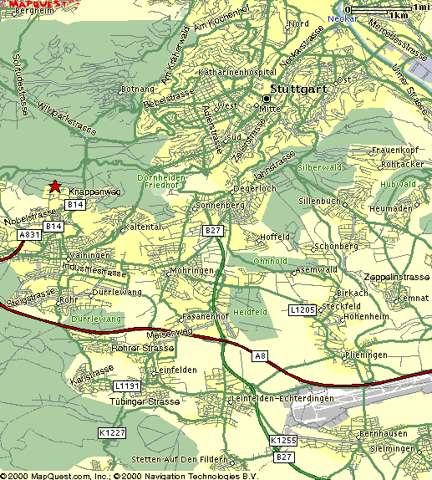

This map focuses on the meeting location:

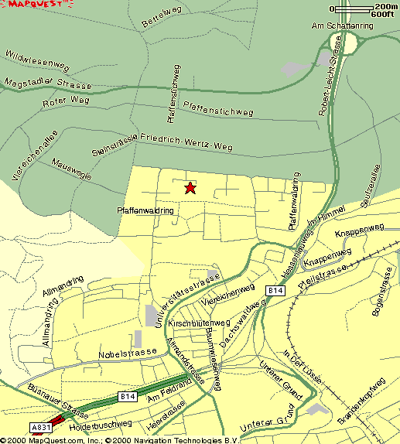

Follow the enclosed hyperlinks to two more maps:
map of the university campus
close-up of the campus shows building 27 near the top of the map where the WG8 meeting will be held. Pfaffenwaldring is the street on the north and the west of the building.

Accommodations
The following is a list of recommended hotels in the area. Fast, public transport is available from all of them.
Downtown:
Rieker am Hauptbahnhof (at the main station)
Friedrichstrasse 3
70174 Stuttgart
+49 711 22 13 11
fax +49 711 29 38 94
(superior class, no restaurant, 61 rooms, 169DM, includes breakfast buffet)

Unger Select Marketing Hotel
Kronenstrasse 17
70173 Stuttgart
+49 711 20 99 0
fax +49 711 20 99 100
(4 star, 189DM, 100 rooms, no restaurant)

Wartburg
Lange Strasse 49
70174 Stuttgart
+49 711 20 45 0
fax +49 711 20 45 450
(3 star, 81 rooms, restaurant)

Best Western Hotel Ketterer
Marienstrasse 3
70178 Stuttgart
+49 711 20 39 0
+49 711 20 39 600
(3 star, 104 rooms, restaurant, single 169-235DM, double 237-275DM, includes breakfast)

Kronen Hotel
Kronenstrasse 48
70174 Stuttgart
+49 711 22 51 0
fax +49 711 22 51 404
(4 star, 84 rooms, no restaurant, 84-322DM)

Ibis Hotel Stuttgart am Loewentor
Presselstrasse 15
70191 Stuttgart
+49 711 25 51 0
fax +49 711 25 51 150
www.ibishotel.com
(132 rooms, no restaurant, 99-119DM for single and double)

Vaihingen-Stuttgart (near university campus):
Not many restaurants are in this area.

Dorint Hotel Fontana
Vollmoellerstrasse 5
70563 Stuttgart
+49 711 730 0
fax +49 711 730 25 25
info.strfon@dorint.com
(4 star, 224 rooms, restaurant)

Roemerhof Hotelbetriebs (entrance of the campus)
Robert-Leicht Strasse 93
70563 Stuttgart
+49 711 68 78 80
fax +49 711 68 78 860
www.hotelroemerhof.de/english
(3 star, 41 rooms, restaurant, single 96-139DM, double 113-179DM includes breakfast buffet, kitchenette single 154DM, double 196DM)

Hotel Lamm
Glockenblumenstrasse 1
70563 Stuttgart
+49 711 73 11 74
fax +49 711 73 15 06
(39 rooms, no restaurant, single 70-95DM, double 249-350DM)

Bildungszentrum Suedwest (Telekom Hotel on campus)
Universitatsstrasse 34
70569 Stuttgart
+49 711 68 63 3
fax +49 711 68 63 48 98
(235 rooms, restaurant, single 98DM, double 118DM)

At the airport: (15 minutes to ISD, 27 min to downtown)

Moevenpick Hotel
Randstrasse 7
+49 711 79 07 0
fax +49 711 793 585
(229 rooms, restaurant, 265-457DM)

Draft Agenda
- Welcome (0900 on 26 February, 2001)
- Roll call and introductions
- Adoption of agenda
- Corrections to, and approval of, the minutes of the last meeting (WG 8 N0116)
- Convener’s report
- National body reports
- Liaison reports
- Editor’s reports
- Appointment of committee for drafting SC24 Recommendations
- Actions from previous WG 8 meetings (WG 8 N0116)
- Other presentations by attendees
- Review of fourth working draft of Environmental Data Coding Standard (EDCS) (WD 18025)
- Agenda items resulting from review of WDs
- Review new action items
- Review the Programme of Work
- Discussion and approval of recommendations to SC 24
- Confirm the dates and place for the next WG 8 meeting
- Close (by 1700 on Friday, 2 March, 2001)

If you plan to make a presentation or provide a written contribution, please indicate your intention no later than one week prior to the start of the meeting. Bring at least 20 copies of any written materials to the meeting with you.

Comments on the document for review should be sent to the Secretariat at least 2 weeks prior to the meeting, i.e., by 12 February 2001.

