ISO/IEC JTC 1/SC 24 WG 8 N0159
Eighth Meeting
ISO/IEC JTC 1/SC 24 Working Group 8 (Environmental Representation)
Palm Springs Hilton
400 East Tahquitz Way, Palm Springs, California, USA
20-24 August 2001

Meeting Announcement and Preliminary Agenda

Meeting
The main purpose of this meeting is to review the drafts of the standards presently being developed. Particular attention will be paid to the WD5 of the Environmental Data Coding Specification and WD3 of the Spatial Reference Model Binding to C.
WG 8 will meet from 0830 until 1700 each day from Monday, 20 August through Friday, 24 August 2001.
Note: All delegates must be authorized by their National Bodies in order to attend the WG 8 meeting.
Registration
Please send e-mail to the meeting Convener, Jack Cogman (jack.cogman@ttsl.thomson-csf.com, with copies to the WG 8 Secretariat, Tim Gifford (tim_gifford@sedris.org) and the meeting host, Dick Puk (puk@igraphics.com), indicating your intent to participate in the WG 8 meeting.
Meeting Host
The meeting is being hosted by Intelligraphics Incorporated, and the contact is
Dr. Richard F. Puk
Intelligraphics Incorporated
Tel: +1-760-753-9027
E-mail: puk@igraphics.com

The exact meeting fee is yet to be determined but will be under $200 per delegate. Please be prepared to pay cash. Personal checks on U.S. banks will also be accepted. However, there will be no provision of payment or the meeting fee by credit card.

Meeting Location
Palm Springs Hilton
400 East Tahquitz Way
Palm Springs, CA 92262
USA
Tel: +1-760-320-6868 or +1-800-541-3129
Fax: +1-760-320-6563
WWW: http://www.hilton.com

All delegates are asked to stay at the Palm Springs Hilton in order to keep the cost of meeting rooms free. The hotel will charge $79 plus tax per night including the $7 per night resort fee. There will be an additional $3 per night energy surcharge. The room block is under the name ISO WG8 and will be held until 4 August 2001. Should there be insufficient delegates staying at the hotel, there may be a meeting fee surcharge for delegates staying elsewhere to cover the cost of renting meeting rooms.

Please indicate any special needs to Dr. Puk as early as possible.
The following map shows downtown Palm Springs with the location of the Hilton annotated:

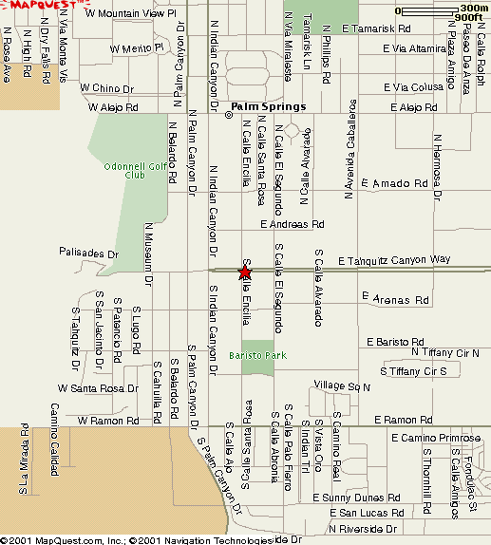

This map focuses on Palm Springs in relation to nearby cities. Palm Springs is the big red star on the right side of the map.

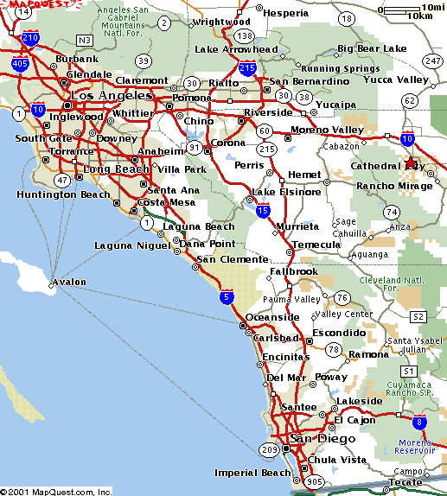
Airports
There are several airports convenient for Palm Springs:
Palm Springs Regional Airport (PSP)
This airport is about three kilometres from the hotel. A list of carriers serving Palm Springs is available at:
http://www.palmsprings.com/services/airport.html
International attendees may be able to get an airfare to Palm Springs for slightly more than the cost of airfare to Los Angeles. There are commuter flights from LAX to Palm Springs. Please check through-rates.
Ontario International Airport (ONT)
This airport is 114 km. (approximately 1 hr. 20 min. driving time) west of Palm Springs and has some limited international connections. The following web site has information about services at the Ontario airport.
http://www.lawa.org/ont/ontframe.html
Los Angeles International Airport (LAX)
This airport is near the coast about three hours drive west of Palm Springs. Bear in mind that driving from LAX is difficult because of Los Angeles traffic. There are extensive international connections from all over the world available through LAX. See the following web site for information:
http://www.lawa.org/lax/laxframe.html

SIGGRAPH Attendees
SIGGRAPH attendees who need to travel to Palm Springs from downtown Los Angeles have the option of renting a car and driving (it’s a straight shot out Interstate 10 from downtown) or checking at the SIGGRAPH travel desk for available shuttle service. It is also possible to take an Amtrak train from Los Angeles Union Station near downtown to Indio and then use a taxi to get to Palm Springs. This may be more expensive than other options.

Climate
The weather will be very dry and very hot. Expect high temperatures to be in the neighborhood of 110° F. or 44° C. It can get chilly in the evenings especially up on top the nearby mountains. The hotel has excellent air conditioning so it should be comfortable at the meeting.
Social Event
There will be a social event on Wednesday evening consisting of a tram ride to the 8 500 foot/ 259 metre level of Mt. San Jacinto where there will be a barbecue buffet dinner. Alcoholic beverages will be available at a cash bar.
Draft Agenda
- Welcome (0830 on 20 August 2001)
- Roll call and introductions
- Adoption of agenda
- Corrections to, and approval of, the minutes of the last meeting (WG 8 N0116)
- Convener’s report
- National body reports
- Liaison reports
- Editor’s reports
- Appointment of committee for drafting SC24 Recommendations
- Other presentations by attendees
- Review of fifth working draft of Environmental Data Coding Standard (EDCS) (WD 18025)
- Review of third working draft of Spatial Reference Model Binding to C (WD 18042)
- Agenda items resulting from review of WDs
- Actions from previous WG 8 meetings (WG 8 N0116)
- Review new action items
- Review the Programme of Work
- Discussion and approval of recommendations to SC 24
- Confirm the dates and place for the next WG 8 meeting
- Close (by 1700 on Friday, 24 August 2001)

If you plan to make a presentation or provide a written contribution, please indicate your intention no later than one week prior to the start of the meeting. Bring an electronic copy or at least 20 printed copies of any written materials to the meeting with you.

Comments on the EDCS document for review should be sent to the Secretariat by 6 August 2001. Comments on the SRM language binding document are due 28 July 2001.

