Tenth Meeting
ISO/IEC JTC 1/SC 24 Working Group 8 (Environmental Representation)

La Fonda on the Plaza
100 East San Francisco St., Santa Fe, New Mexico, USA
17 – 21 February 2002

Meeting Announcement and Preliminary Agenda

Meeting
The main purpose of this meeting is to review the drafts of the standards presently being developed. Particular attention will be paid to Clauses 1 – 4 of WD 6 of the SRM, and WD1 of SEDRIS-Part 2: Abstract SEDRIS Transmittal Format.

WG 8 will start at 1330 on Sunday, 17 February 2002 and conclude for the day at 1800. We will meet from 0800 until 1800 each remaining day through Thursday, 21 February 2002.

Note: All delegates must be authorized by their National Bodies in order to attend the WG 8 meeting.

Registration
Please send e-mail to the meeting Convener, Jack Cogman (jack.cogman@thales-tts.com), with copies to the WG 8 Secretariat, Tim Gifford (tim_gifford@sedris.org), and the meeting host, Steve Carson (carson@gscassociates.com), indicating your intent to participate in the WG 8 meeting.

Meeting Fee
The exact meeting fee is yet to be determined but will likely be under $200 per delegate. Please be prepared to pay in cash, traveller’s check or a personal or company check on a U.S. bank. You will not be able to pay the meeting fee by credit card.
There will be a social event at the hotel on Wednesday evening. The cost is included in the meeting fee and extra tickets can be purchased for guests.

Meeting Host
The meeting is being hosted by GSC Associates. The local contact is
Steve Carson
GSC Associates
5272 Redman Road
Las Cruces, NM 88011
Tel: +1-505-521-7399
E-mail: carson@gscassociates.com

Meeting Location
La Fonda on the Plaza
100 East San Francisco Street
Santa Fe, New Mexico
USA
Tel: +1-505-995-2321 or in the USA, +1-800-523-5002
Fax: +1-505-995-2324
Web: http://www.lafondasantafe.com/
The New Mexico Department of Tourism has a web site at: http://www.newmexico.org/
The Santa Fe Convention and Visitor’s Bureau has a web site at: http://www.santafe.org/
All delegates are asked to stay at La Fonda to keep the cost of the meeting room complimentary. The hotel will charge the $99.00 single occupancy and $15.00 additional for double occupancy plus a lodger’s tax per night of $5.00 and a gross receipts tax of 6.4375%.

Reservation Method
Reservations must be made individually by phone or fax and must be received by noon of the cut-off date of Tuesday, 15 January 2002. The room block is under the name SEDRIS.
The group rate will be honoured 3 days before and after the meeting dates, based on availability. There are no rooms reserved in the block for Saturday night 16 February 2002 (the night prior to the meeting) or for Friday night 22 February (the night after the meeting) so if your plans call for staying these nights in Santa Fe, it is advisable that you make your reservations very early since La Fonda normally sells out well in advance every weekend.
Please indicate any special needs to Steve Carson by e-mail (mailto:carson@gscassociates.com) as early as possible.

Driving Directions
From Albuquerque, NM:
- Take I-25 north to exit 284 (Old Pecos Trail).
- Turn left onto Old Pecos Trail staying in the far right hand lane this becomes Old Santa Fe Trail.
- Go past the Zia stoplight.
- After you pass the Capitol building and the Hotel Loretto, the street jogs to the left and you are at La Fonda.
- At the first stop sign, turn right onto San Francisco Street.
- At the end of the block is St. Francis Cathedral. La Fonda’s parking garage (Carriage House) is directly across from the church. As guests check in at the La Fonda, they will receive a sticker for their vehicle indicating that they are guests of the hotel.
From the Santa Fe, NM Airport:
- Turn left onto Airport Road. This turns into Rodeo Road and will eventually intersect with Old Santa Fe Trail.
- Make a right onto Old Santa Fe Trail.
- Turn right at Hotel Loretto.
- At the first stop sign, turn right onto San Francisco Street.
- At the end of the block is St. Francis Cathedral. La Fonda’s parking garage (Carriage House) is directly across from the church.
The following map shows downtown Santa Fe with the location of La Fonda annotated.
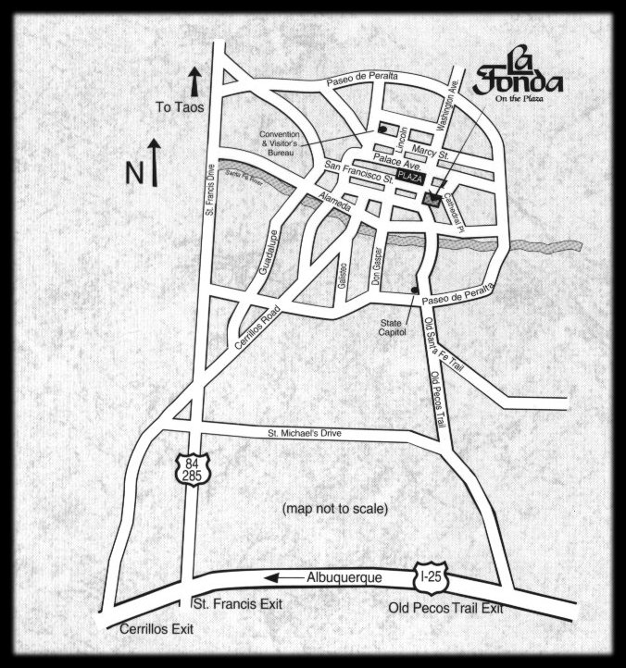

Airports
Santa Fe is located in north central New Mexico, an hour's drive north of Albuquerque. Albuquerque International Airport is serviced by all major U.S. airlines
Santa Fe Municipal Airport is located 11.5 miles from downtown Santa Fe. At present it is serviced by one commuter airline, as well as being open to private aircraft. It serves commercial flights from Denver via United Express (flying Beechcraft 100 TurboProp planes). The Roadrunner Shuttle meets all arriving flights and offers transport to local hotels for a rate of $11 per person or $8 per person for groups. Roadrunner will schedule pickup and return trips to the airport with reservations (424-3367).

Transportation
It is not necessary to have a rental car in Santa Fe as there are many restaurants and shops within walking distance of the hotel as well as excellent local bus service. Because of this and the $9.00 a day that the hotel charges for parking (there is no free on-street parking in downtown Santa Fe) we do not recommend that you rent a car but rather that you use one of the shuttle bus services from the Albuquerque or Santa Fe airports.
Several shuttle services provide transportation 7 to 10 times daily between the Albuquerque International Airport and downtown Santa Fe hotels. The following web sites provides a current list of shuttle services operating between Santa Fe and the Albuquerque airport:
http://www.santafestation.com/features/shuttle/shuttle.html
http://www.santafe.org/f.html?nav2.html+comingtosf.html
The following companies currently provide shuttle service. For more details, contact them directly or check their web sites:
Sandia Shuttle Express – 1-888-775-5696, Albuquerque, 1-505-243-3244,
Santa Fe, 1-505-474-5696 or http://www.sandiashuttle.com/
One way $20.00, reservations required for guaranteed seating.
Santa Fe Shuttle – 1-888-833-2300, Albuquerque, 1-505-243-2300, http://www.santafeshuttle.com/
One way $21.00
Round trip $38.00
Twin Hearts Express Transportation Shuttle (Santa Fe, Tacos Ski Valley, Red River, Espanola and Southern Colorado) 1-800-654-9456 or 1-505-751-1201
One way $20.00
There is local bus service around Santa Fe. You can find out the schedules and routes at:
http://www.santafe.com/directionsclick.htm

Parking
The charge for parking an automobile in La Fonda’s garage (“Carriage House” Garage) is currently $9.00 per day, allowing for unlimited “in-and-out” access.

Climate
Santa Fe is located in a high mountain valley at an altitude of 7,000 feet. The average temperature in February is 7 degrees Celsius (45 degrees Fahrenheit) during the day and –7 degrees Celsius (20 degrees Fahrenheit) in the evening. Snowfall varies in February, but a heavy snowfall is possible.

Draft Agenda
- Welcome (1330 17 February 2002)
- Roll call and introductions
- Adoption of agenda
- Corrections to, and approval of, the minutes of the last meeting (WG 8 N0189)
- Convener’s report
- National body reports
- Liaison reports
- Editor’s reports
- Appointment of committee for drafting SC24 Recommendations
- Other presentations by attendees (to be notified in advance)
- Review of clauses 1 – 4. sixth working draft of the SRM (WG 9 N0195)
- Review of the first working draft of SEDRIS-Part 2: Transmittal Format (WG 8 N0190)
- Agenda items resulting from review of WDs
- Actions from previous WG 8 meetings (WG 8 N0189)
- Review new action items
- Review the Programme of Work
- Discussion and approval of recommendations to SC 24
- Confirm the dates and places for future WG 8 meetings
- Close (by 1800 on Thursday, 21 February 2002)
If you plan to make a presentation or provide a written contribution, please indicate your intention no later than one week prior to the start of the meeting. Bring an electronic copy or at least 20 printed copies of any written materials to the meeting with you.
Comments on the SEDRIS-Part 2 document for review should be sent by the NBs and LOs to the Secretariat by 1 February 2002. Comments on the SRM WD 6 document for review should be sent to the Secretariat by 13 February 2002.

