ISO/IEC JTC 1/SC 24 WG 8 N0244

Thirteenth Meeting
ISO/IEC JTC 1/SC 24 Working Group 8 (Environmental Representation)
SAIC, Orlando, Florida
9 - 13 December 2002

Meeting Announcement and Preliminary Agenda

Meeting
The main purpose of this meeting is to review the drafts of the standards presently being developed, in particular the review of the comments on SEDRIS Part 1, Functional Specification, WD 6 18023-1. Unfortunately, the SEDRIS Language Bindings, Part 4: C, WD6 18024-4, which was scheduled to be reviewed at this meeting, will not be ready in time.

WG 8 will meet from 0830 until 1700 on Monday, 9 December and from 0830 until 1700 each day thereafter through Friday, 13 December 2002.
Note: All delegates must be authorized by their National Bodies in order to attend the WG 8 meeting.
Registration and Meeting Logistic Information
Please send e-mail to the meeting Convenor, Jack Cogman (jack.cogman@thales-tts.com), with a copy to the WG 8 Secretariat, Tim Gifford (tim_gifford@sedris.org), and the meeting host, Rob Cox (coxr@saic.com), indicating your intent to participate in the WG 8 meeting.

Meeting Location
SAIC
12901 Science Drive
Orlando, FL 32826-3014
407-282-3700 Fax: 407-243-3311

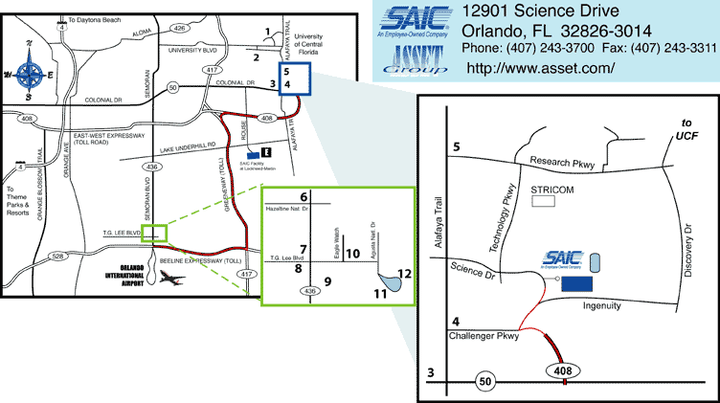
(Download a printable version of this map - pdf 295k)

http://www.asset.com/locations/orlando/orlando_map.html

Transportation
The hotels listed below, marked with an asterisk, provide transportation to and from the airport. The price is listed for one-way. In addition, the hotels marked with two asterisks, will provide transportation to and from SAIC, again with the price listed. While some of the hotels provide transportation and some restaurants are within a short walking distance, you may wish to hire a car from one of the car rental agencies at the airport.

Directions
From Orlando International Airport (1/2 hour):
Take North exit out of the airport.
Go east on 528 (Beeline Expressway) towards Cocoa.
Take exit 16, north 417 (Greenway, .50 toll).
Take exit 33A, east 408 (East-West Expressway, toll road) towards Titusville.

If you are going to the hotels: Exit at Alafaya Trail, proceed north.
If you are going to SAIC: Stay on east 408 until the expressway ends.
Take your first right, Ingenuity Drive.
Take the first left, Science Drive.
SAIC is on the right.

Area Hotels
The following is a listing of hotels in the area. The numbers correlate to the numbers on the map to the meeting location.

1 – Holiday Inn/UCF 4 – Comfort Suites
12125 High Tech Ave. 12101 Challenger Pkwy
Orlando, FL 32817 Orlando, FL 32826
(407) 275-9000 (407) 737-7303
*$30, **$0

2 – Courtyard Marriott/UCF 5 – LaQuinta Inn
12000 Collegiate Way 11805 Research Pkwy
Orlando, FL 32817 Orlando, FL 32826
(407) 277-7676 (407) 737-6075
*$40, **$5

3 – Radisson University Hilton Garden Inn
17724 Alafaya Trail 1959 Alafaya Trail
Orlando, FL 32826 Orlando, FL 32826
(407) 658-9008 (407) 992-5000
*$35, **$0 *$40, **$2

Meeting Cost
The meeting cost per person is $40 US dollars. Final costs may be refigured the week of the meeting.

Draft Agenda

- Welcome (0830, 9 December 2002)
- Roll call and introductions
- Adoption of agenda
- Corrections to, and approval of, the minutes of the last meeting update (WG 8 N0242)
- Convenor's report
  - Editors for EDCS and SRM
  - Request for Schedule Extension
  - JTC1 Plenary
- National body reports
- Liaison reports
- Editor's reports
- Other presentations by attendees
- Appointment of drafting committee for recommendations to SC 24
- ISO/IEC 18023 SEDRIS
  - Proceeding with SEDRIS parts 2 and 3
  - Review of SEDRIS Part 1, Sixth Working Draft
  - Registration issues
- Agenda items resulting from review of WDs
- Discussion on ISO/19126: Profile FACC Data Dictionary
- Discussion on ISO 19135: Procedures for Registration of geographic information items
- Review the Programme of Work
- Confirm the dates and places for future WG 8 meetings
- Discussion and approval of recommendations to SC 24
- Actions from previous WG 8 meetings (WG 8 N0242)
- Review new action items.
- Close (1700, 13 December 2002)

If you plan to make a presentation or provide a written contribution, please indicate your intention no later than one week prior to the start of the meeting. Bring 20 copies of any written materials to the meeting with you.

Comments on the documents for review should be sent to the Secretariat no later than 1 December 2002.

