ISO/IEC JTC 1/SC 24/WG 8 N0268

Fourteenth Meeting
ISO/IEC JTC 1/SC 24 Working Group 8 (Environmental Representation)

Institut fuer Statik u. Dynamik der Luft und Raumfahrtkonstruktionen (ISD)
Pfaffenwaldring Bldg. 27, Stuttgart, Germany

4 – 8 April 2003

Meeting Announcement and Preliminary Agenda

Meeting
The main purpose of this meeting is to review the drafts of the standards presently being developed. Particular attention will be paid to the SRM, WD 7 (ISO/IEC 18026) and the SRM Language Binding to C WD 4 (ISO/IEC 18042).
WG 8 will meet from 0900 until 1700 each day from Friday, 4 April through Tuesday, 8 April 2003.
Note: All delegates must be authorized by their National Bodies in order to attend the WG 8 meeting.
Registration
In addition to being authorized by your National Body or Liaison Organization, please send an e-mail to the meeting Convenor, Jack Cogman (jack.cogman@thales-tts.com), with a copy to the WG 8 Secretariat, Tim Gifford (tim_gifford@sedris.org), indicating your intent to participate in the WG 8 meeting.
Meeting Host
The meeting is being hosted by the University of Stuttgart, and the contact is
Dr. Ingolf Grieger
Institut fuer Statik u. Dynamik (ISD)
Tel: +49 711-685-3636
E-mail: grieger@isd.uni-stuttgart.de

The meeting fee will be 50 Euros.
Meeting Location
Institut fuer Statik u. Dynamik der Luft
Und Raumfahrtkonstruktionen (ISD)
Pfaffenwaldring 27 in Stuttgart-Vaihingen
70550 Stuttgart, Germany
Tel: +49 711-685-3636

It is difficult to provide instructions on how to arrive at the meeting location without knowing from where each person is lodging. Therefore, maps are provided. You may also request instructions from your lodging place. It is not necessary to hire a automobile. The campus is accessible by the S-Bahn. There is a map on the home page of the ISD:
http://www.isd.uni-stuttgart.de

The following map shows Stuttgart in the north, the university marked with a “star” in the west, and the airport is seen in the southeast corner:

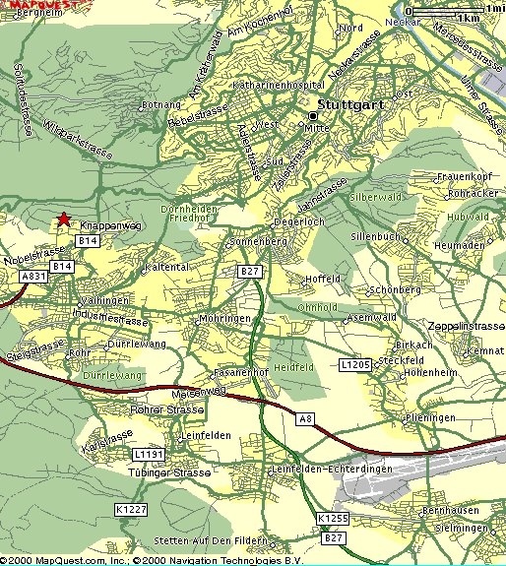

This map focuses on the meeting location:

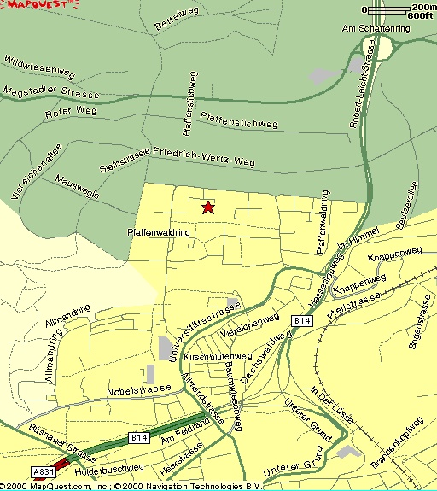

Follow the enclosed hyperlinks to two more maps:
map of the university campus
close-up of the campus shows building 27 near the top of the map where the WG8 meeting will be held. Pfaffenwaldring is the street on the north and the west of the building.

Accommodations
The following is a list of recommended hotels in the area. Fast, public transport is available from all of them. In addition, to ensure availability, a small block of rooms has been requested at the Best Western Hotel Ketterer. Several of the attendees at the previous Stuttgart stayed in this hotel and found it both suitable and convenient. The block expires on 28 February.
Downtown:
Rieker am Hauptbahnhof (at the main station)
Friedrichstrasse 3
70174 Stuttgart
+49 711 22 13 11
fax +49 711 29 38 94
(3 star, no restaurant, 61 rooms, single 90-102 Euro, double 100-142 Euro, includes breakfast buffet)

Unger Select Marketing Hotel
Kronenstrasse 17
70173 Stuttgart
+49 711 20 99 0
fax +49 711 20 99 100
(4 star, 100 rooms, no restaurant, single 102-123 Euro, double 143-179 Euro)

Wartburg
Lange Strasse 49
70174 Stuttgart
+49 711 20 45 0
fax +49 711 20 45 450
(3 star, 81 rooms, restaurant, single 83-87 Euro, double 125-137 Euro)

Best Western Hotel Ketterer
Marienstrasse 3
70178 Stuttgart
+49 711 20 39 0
+49 711 20 39 600
(3+ star, 104 rooms, restaurant, single 89-125 Euro, double 117-237 Euro,
includes breakfast)

Kronen Hotel
Kronenstrasse 48
70174 Stuttgart
+49 711 22 51 0
fax +49 711 22 51 404
(4 star, 84 rooms, no restaurant, single 99-120 Euro, double 133-175 Euro)
Vaihingen-Stuttgart (near university campus):
Not many restaurants are in this area.

Dorint Hotel Fontana
Vollmoellerstrasse 5
70563 Stuttgart
+49 711 730 0
fax +49 711 730 25 25
info.strfon@dorint.com
(4 star, 224 rooms, restaurant, single 96-223 Euro, double 112-254 Euro)

Roemerhof Hotelbetriebs (entrance of the campus)
Robert-Leicht Strasse 93
70563 Stuttgart
+49 711 68 78 80
fax +49 711 68 78 860
www.hotelroemerhof.de/english
(3 star, 41 rooms, restaurant, single 58-81 Euro, double 78-96 Euro
includes breakfast buffet)

Hotel Lamm
Glockenblumenstrasse 1
70563 Stuttgart
+49 711 73 11 74
fax +49 711 73 15 06
(39 rooms, no restaurant, single 62 Euro, double 82-120 Euro)

Tagungshotel deutsche Telekom AG (on campus)
Universitatsstrasse 34
70569 Stuttgart
+49 711 68 63 3
fax +49 711 68 63 48 98
(235 rooms, restaurant, single 35-52, double 47-92)

At the airport: (15 minutes to ISD, 27 min to downtown by train)

Moevenpick Hotel
Randstrasse 7
+49 711 79 07 0
fax +49 711 793 585
(229 rooms, restaurant)

Getting to Stuttgart
Stuttgart has an international airport and is readily accessed by rail from other cities with airports such as Frankfurt and Munich. The URL for the Deutsche Bahn (rail) Travel Planner tool is http://reiseauskunft.bahn.de/bin/query.exe/en?ld=107&newrequest=yes&

Draft Agenda
1. Welcome (0900 on 4 April, 2003)
2. Roll call and introductions
3. Adoption of agenda
4. Corrections to, and approval of, the minutes of the last meeting (WG 8 N0259)
5. Convenor’s report
6. National body reports
7. Liaison reports
− DGIWG Working Party – P. Birkel
− TC 211 19126 and 19135 Editing Meeting – P. Birkel
− TC 211 approach to registries - P.Birkel
8. Rapporteur's Report
- Demonstration of prototype registry
- Proposed amendments to ISI/IEC 9973
9. Editor’s reports
10. Appointment of committee for drafting SC24 Recommendations
11. Other presentations by attendees
12. Review of seventh working draft of Spatial Reference Model (SRM) (WD 18026)
13. Review of fourth working draft of SRM Language Binding (WD 18042)
14. Agenda items resulting from review of WDs
15. Actions from previous WG 8 meetings (WG 8 N0259)
16. Review new action items
17. Review the Programme of Work
18. Discussion and approval of recommendations to SC 24
19. Confirm the dates and place for the next WG 8 meeting
20. Close (by 1700 on Tuesday, 8 April 2003)

Note: In the event that further discussion is required on either the prototype registry or the registration process in general, then allowance should be made for a Workshop to be held the following day, Wednesday 9 April.

If you plan to make a presentation or provide a written contribution, please indicate your intention no later than one week prior to the start of the meeting. Bring at least 20 copies of any written materials to the meeting with you.

Comments on the documents for review should be sent no later than 31 March 2003 to the Secretariat (tim_gifford@sedris.org).

