ISO/IEC JTC 1/SC 24/WG 8 N0331

ISO/IEC JTC 1/SC 24
Working Group 8
Seventeenth Meeting
Crawley, UK
30 January to 6 February 2004

Meeting Announcement and Preliminary Agenda

Meeting
The main purpose of this meeting is to host, facilitate and respond to the results of the editing meetings for the SEDRIS Part 1 - SEDRIS Functional Specification CD2 18023-1, SEDRIS Part 2 - Abstract Transmittal Format CD 18023-2, and SEDRIS Part 3 - SEDRIS Transmittal Format Binary Encoding CD 18023-3. Because there has been concern about five days not being enough time to review all three standards, we have added two extra meeting days to allow a day each for the SEDRIS Parts 2 and 3 editing meetings.

WG 8 will meet from 0900 until 1700 on Friday, 30 January and from 0830 until 1700 each day thereafter through Friday, 6 February 2004, except for Sunday, 1 February, when there will be no meeting.
Note: All delegates must be authorized by their National Bodies in order to attend the WG 8 meeting.

Registration and Meeting Logistic Information
Please send e-mail to the meeting Convenor, Jack Cogman (jack.cogman@thales-tts.com), with a copy to the WG 8 Secretariat, Tim Gifford (tim_gifford@sedris.org), indicating your intent to participate.

Meeting Location
Barnwood Hotel
Balcombe Road, Pound Hill
Crawley, West Sussex RH10 7RU
United Kingdom
+44 (0)1293 425800 Fax: +44 (0)1293 425808
e-mail reception@barnwood.co.uk
http://www.barnwood.co.uk

Please indicate “SC 24/WG8” to book your room for the meeting delegate rate. You have two choices for booking rates. The first is £80/day inclusive of accommodation, breakfast, buffet lunch, evening meal and conferences facilities or £40/day for room + £7.50 breakfast + £15 (approximately) evening meal +£22.50 conference facilities, including buffet lunch. You do not have to choose which tariff until you register at the hotel. On Sunday when an evening meal is not available, we have been assured we not be charged the full £80/day. All delegates are requested to stay at the Barnwood Hotel in order for the group to obtain these meeting rates.

Transportation
The Barnwood is just south of Gatwick Airport and in easy distance via a taxi (one-way fare £10). If you must fly into Heathrow Airport rather than Gatwick, there is train service available. The train station closest to the Barnwood is Three Bridges Station. From there you would need to get a taxi. This information for trains and bus services may be reached through links from the Barnwood Hotel URL above. There is one good pub in easy walking distance of the hotel and another within reasonable walking distance.

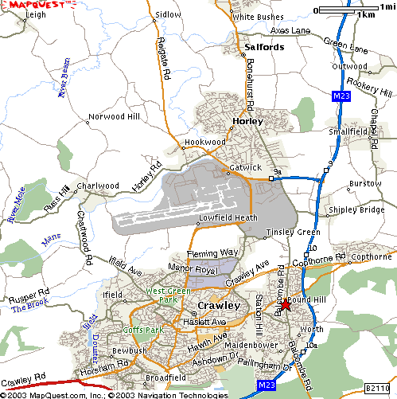

Directions from Gatwick Airport
Follow signs for the M23 southbound. When on the M23, look for Junction 10A and exit at this junction. Turn right over motorway to another roundabout, following signpost towards Horley and Town Centre straight over next round-about. The hotel is approximately 400 metres on left-hand side.

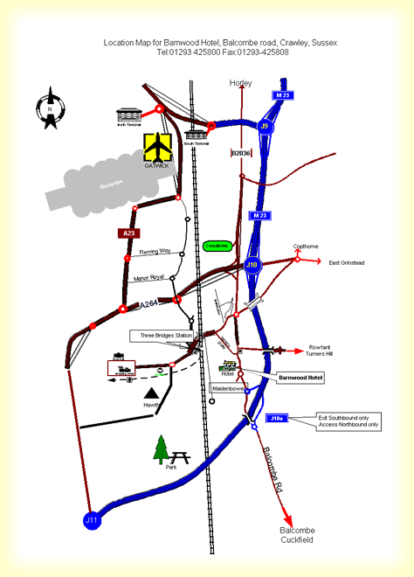

Meeting Cost
There is no other meeting cost besides the delegate rate which is charged by the hotel for your room.
Draft Agenda

- Welcome (0900, 30 January 2004)
- Roll call and introductions
- Adoption of agenda
- Corrections to, and approval of, the minutes of the December meeting
- Appointment of drafting committee for recommendations to SC 24
- Editing meetings for any comments received on:
  - ISO/IEC CD 2 18023-1 SEDRIS Functional Specification
  - ISO/IEC CD 18023-2 SEDRIS Transmittal Format
  - ISO/IEC CD 18023-3 SEDRIS Transmittal Format Binary Encoding
------------------------------------------------------------------------------------------------------------
(The below items are planned for the last half day.)
- Convenor's report
- National body reports
- Liaison reports
- Editors reports
- Other presentations by attendees
- Agenda items resulting from review of CDs
- Review the Programme of Work
- Confirm the dates and places for future WG 8 meetings
- Discussion and approval of recommendations to SC 24
- Actions from previous WG 8 meetings
- Review new action items
- Close (1700, 6 February 2004)

If you plan to make a presentation or provide a written contribution, please indicate your intention no later than one week prior to the start of the meeting. Bring 15 copies of any written materials to the meeting with you.
Comments on the documents for review should be sent to the SC 24 Secretariat in accordance with the balloting instructions. As always, a courtesy copy of the comments is appreciated by the WG 8 Secretariat. The due date for ballots and comments to SC 24 on SEDRIS Part 1 is 27 January 2004 and for SEDRIS Parts 2 and 3, the due date is 9 January 2004.

