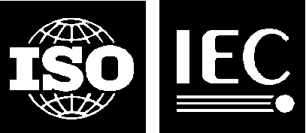 |  | ISO/IEC JTC1/SC24 WG8 N0601

Our ref.: TG/gw

Date: 7 November 2015

Secretariat of ISO/IEC JTC 1/SC 24 WG 8
Environmental Representation

Title: Presentation on Reuse and Interoperation of Environmental Data and Processes (RIEDP), 31st SC 24/WG 8 Meeting, August 2015, London, UK

Source: Sogitec

Replaces: N/A

Document Type: Presentation

Projects: ISO/IEC 18023 – 18026, 18041, 18042, 9973

Status: Presented at the 31st SC 24/WG 8 Meeting

Action ID: FYI

Due Date: N/A

Distribution: WG 8 Members, SC 24 Secretariat, SC 24 Chairman and
WG Convenors

Date of Distribution: 7 November 2015

Distribution Medium: Web

Batch No: 8/D360

No of pages: 20 (+1 cover page)

