ISO/IEC JTC 1/SC 24 N3952
ISO/IEC JTC 1/SC 24/WG 8 N0616

ISO/IEC JTC 1/SC 24/WG 8
(Environmental Data Representation)
WG 8 Meeting 33
Arlington, Virginia (VA), USA
07 - 11 August 2017

WG 8 Meetings and Agenda

Meeting Logistics and Registration

The logistics details for the 2017 SC 24 Arlington meetings are given in SC 24 document SC 24 N3932.
As some WG 8 members may not be able to travel, web conferencing facilities are being provided to allow such members to participate in the meetings via web/phone (WebEx).

Contacts / Local Organizer
The meetings will be hosted by the American National Standards Institute (ANSI) on behalf of INCITS H3, the ANSI Mirror Group for SC 24.
For questions related to this meeting please contact:
Bill Protzman, Chairman, INCITS H3
wprotzman@dcscorp.com
Tel: +1-571-227-6181
Mob: +1-443-257-2542

Meeting Dates
Monday 07 August – Friday 11 August

Initial Meeting Plan
The JTC 1/SC 24 draft meeting plan for all WG and SC 24 meetings is provided in Annex 1 of this document. The agenda for WG 8 meetings are given in this document.
Meeting Location
The meetings are being held at the Virginia Tech Executive Briefing Center – Arlington, which is located on the 2nd floor of the Virginia Tech Research Center building in Arlington, VA at
900 N. Glebe Road
Arlington, VA 22203
Phone: 571-858-3044
The Virginia Tech Executive Briefing Center is located approximately 7 miles outside of Washington, D.C. and is within easy walking distance of many hotels, restaurants, shops, attractions, and the Washington Subway (Metro). The closest Metro stop is the Ballston-MU station on the Orange and Silver Lines and is approximately a 0.3 mile walk from the facility. Additional direction details are available at http://www.ncr.vt.edu/Arlington/Directions.html.
Registration
National Delegations and Liaison Officers to ISO/IEC JTC 1/SC 24 should be identified to the JTC 1/SC 24 Secretary through their National Bodies or Liaison Organizations. National Bodies and Liaison Organizations must inform the SC 24 Secretary of who will be representing them in their delegations at the Plenary meetings, and who will be authorized to attend the HOD/C meetings (in accordance with the ISO/IEC Directives Part 1 - Consolidated JTC 1 Supplement).
The Registration Form provided in SC 24 N3933 is the means to formally notify the SC 24 Secretariat of who is authorized to attend the proceedings of ISO/IEC JTC 1 SC 24. WG attendees must be registered in the Global Registry.
Persons participating only by web/phone do not need to register, but should inform the SC 24 Secretariat and the relevant WG Convenor by email of their plan to participate remotely.
Please forward completed registration forms to:
Charles Whitlock, SC 24 Secretariat: charles.whitlock@bsigroup.com
with copy to:
Bill Protzman: wprotzman@dcscorp.com.

Meeting Plan

The WG 8 meetings will consist of:

Working Session: Wednesday, 9 August 2017
0830 – 1200 Arlington, VA, USA (Eastern)
which corresponds to:
2030 – 2359 Beijing, China (Eastern)
1430 – 1800 Europe (Central)
1330 – 1700 UK
0530 – 0900 USA (Pacific)

WG 8 Plenary: Thursday, 10 August 2017
0830 – 1000 Arlington, VA, USA (Eastern)
which corresponds to:
2030 – 2200 Beijing, China (Eastern)
1430 – 1600 Europe (Central)
1330 – 1500 UK
0530 – 0700 USA (Pacific)

The SC 24 Plenary: Friday, 11 August 2017, 0830 - 1300.

Other meetings, at which WG 8 members are encouraged to attend, are at the following times in Arlington:
- 08.30 – 17.30 Monday, 7 August: Technical Presentations - These will be applicable to all members of SC 24
- WG 6 Plenary – 1300 – 1430 Wednesday, 9 August
- WG 7 Plenary – 1500 – 1630 Wednesday, 9 August
- WG 9 Plenary – 1030 – 1200 Thursday, 10 August

The timetable for all the meetings held in Arlington is given in Annex A.

WG 8 Working Session

Arlington, VA, USA - 2017

Agenda

Wednesday, 9 August 2017
0830 – 1200 Arlington, VA, USA (Eastern)
which corresponds to:
2030 – 2359 Beijing, China (Eastern)
1430 – 1800 Europe (Central)
1330 – 1700 UK
0530 – 0900 USA (Pacific)

- Welcome and Introductions – Jack Cogman, WG 8 Convenor
- Pending Work Projects:
  - ISO/IEC 18023-1 Ed. 2, SEDRIS Part 1 Revision
  - ISO/IEC 18023-3 Ed. 2, SEDRIS Part 3 Revision
  - ISO/IEC 18024-4 Ed. 2, SEDRIS Language Binding Revision
  - ISO/IEC 18026 Ed. 3, SRM Revision
  - ISO/IEC 18042-4 Ed. 2, SRM Language Binding Revision
All the above projects are on hold at present, but the status of each will be reviewed.
- Work Schedule
- EDCS Registry
- Recent Changes to SC 24 Register
- Migration of WG 8 Document Register to LiveLink
- Related Work of SISO RIEDP (Reuse and Interoperation of Environmental Data and Processes)
- WG 8 Work Items related to other JTC 1 SCs and WGs
- Presentations not shown on Monday
- Current status of Action Items
- Review of the WG 8 work programme and revision, if necessary
- Draft recommendations to be forwarded to the WG 8 Plenary meeting

Back to Top

WG 8 Plenary

33rd WG 8 Plenary – Arlington, VA 2017

Agenda

Thursday, 10 August 2017
08.30 – 1000 Arlington, VA, USA (Eastern)
which corresponds to:
2030 – 2200 Beijing, China (Eastern)
1430 – 1600 Europe (Central)
1330 – 1500 UK
0530 – 0700 USA (Pacific)

- Welcome
- Roll call and introductions
- Corrections to, and approval of, the minutes of the 32nd meeting held in Beijing
- Convenor's report
- Summary of key topics from the Working Session
- National body reports
- Liaison reports
- DGIWG
- SEDRIS
- SISO
- Other
- Editor reports
- ISO/IEC 9973
- EDCS and EDCS LB
- SRM and SRM LB
- SEDRIS Parts 1, 2, and 3
- SEDRIS LB
- Reports from the registry rapporteurs
- Appointment of registry rapporteurs
- EDCS
- SRM
- SEDRIS
- Summary of WG 8 content in the draft SC 24 Business Plan for 2017-18
- Work Schedule
- Discussion and approval of recommendations to SC 24
- Review action items
- Adjourn

Annex A

Meeting Plan

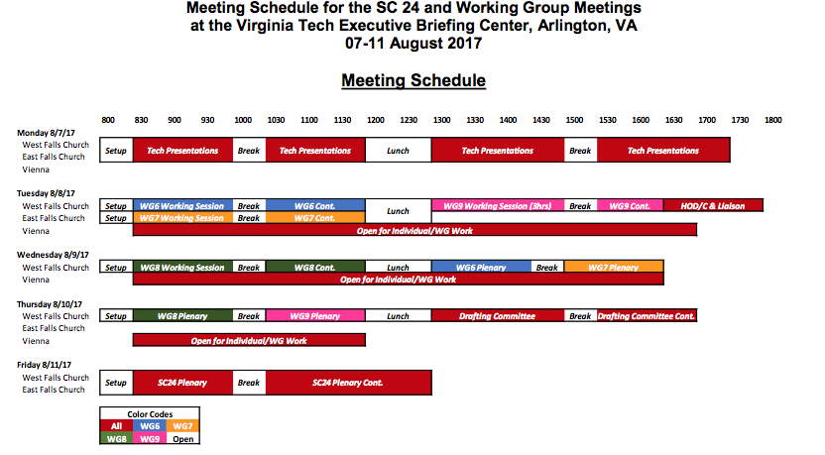
Back to Top

