ISO/IEC JTC 1/SC 24/WG 8 N0629

ISO/IEC JTC 1/SC 24/WG 8
(Environmental Data Representation)
WG 8 Meeting 34
Vigoulet-Auzil, Toulouse, France
6 - 10 August 2018

WG 8 Meetings and Agenda

Meeting Logistics and Registration

The logistics details for the 2018 SC 24 Toulouse meetings are given in SC 24 document SC 24 N4063.
As some WG 8 members may not be able to travel, web conferencing facilities are being provided to allow such members to participate in the meetings via web/phone.

Contacts / Local Organizer
The meetings will be hosted by OKTAL-SE in conjunction with the SEDRIS Organization and in co-ordination with AFNOR.
For questions related to this meeting please contact:
Carole Nissoux, Jean Latger, or Ingrid Gau (Local Organizers)
carole.nissoux@oktal-se.fr
jean.latger@oktal-se.fr
ingrid.gau@oktal-se.fr
Oktal-SE Tel: +33 5 67 70 02 00 Carole Nissoux: +33 6 66 14 41 65

or Farid Mamaghani: farid@sedris.org

or Charles Whitlock: charles.whitlock@bsigroup.com

Meeting Dates
Monday 06 August – Friday 10 August 2018

Initial Meeting Plan
The JTC 1/SC 24 updated draft meeting plan for all WG and SC 24 meetings is provided in Annex 1 of this document. The agenda for WG 8 meetings are given in this document.
Meeting Location
The meetings are being held at the OKTAL-SE facilities located in Vigoulet-Auzil (near Toulouse, France) at:
11, avenue du Lac
31 320 Vigoulet-Auzil – France
Phone: 33 (0)5 67 70 02 00
OKTAL-SE is located about 15 km from downtown Toulouse.
Registration
National Delegations and Liaison Officers to ISO/IEC JTC 1/SC 24 should be identified to the JTC 1/SC 24 Secretary through their National Bodies or Liaison Organizations. National Bodies and Liaison Organizations must inform the SC 24 Secretary of who will be representing them in their delegations at the Plenary meetings, and who will be authorized to attend the HOD/C meetings (in accordance with the ISO/IEC Directives Part 1 - Consolidated JTC 1 Supplement).
The Registration Form provided in SC 24 N 4069 is the means to formally notify the SC 24 Secretariat of who is authorized to attend the proceedings of ISO/IEC JTC 1 SC 24. WG attendees must be registered in the Global Registry.
Persons participating only by web/phone do not need to register, but should inform the SC 24 Secretariat and the WG 8 Convenor by email (jack.cogman@datasim.net) of their plan to participate remotely.
Please forward completed registration forms to:
Charles Whitlock, SC 24 Secretariat: charles.whitlock@bsigroup.com
with copy to:
Carole Nissoux: carole.nissoux@oktal-se.fr and Farid Mamaghani: farid@sedris.org .

Meeting Plan

The WG 8 meetings will consist of:

Working Session:
Wednesday, 8 August 2018
0830 – 1200 Toulouse, France
which corresponds to:
1430 – 1800 Beijing (China Standard Time)
0730 – 1100 UK
0230 – 0600 USA (East Coast)
2330 – 0300 USA (Pacific)

WG 8 Plenary:
Thursday, 9 August 2018
08.30 – 1000 Toulouse, France
which corresponds to:
1430 – 1600 Beijing (China Standard Time)
0730 – 0900 UK
0230 – 0400 USA (East Coast)
2330 – 0100 USA (Pacific)

The SC 24 Plenary: Friday, 10 August 2018, 0830 - 1300.

Other meetings, at which WG 8 members are encouraged to attend, are at the following times:
- 08.30 – 17.30 Monday, 6 August: Technical Presentations - These will be applicable to all members of SC 24
- WG 6 Plenary – 1300 – 1430 Wednesday, 8 August
- WG 7 Plenary – 1500 – 1630 Wednesday, 8 August
- WG 9 Plenary – 1030 – 1200 Thursday, 9 August

The timetable for all the meetings held in Arlington is given in Annex A.

WG 8 Working Session
OKTAL-SE, Toulouse, France - 2018
Agenda

Wednesday, 8 August 2018
0830 – 1200 Toulouse, France
which corresponds to:
1430 – 1800 Beijing (China Standard Time)
0730 – 1100 UK
0230 – 0600 USA (East Coast)
2330 – 0300 USA (Pacific)
Chair: Jack Cogman
- Welcome and Introductions
- Pending Work Projects:
  - ISO/IEC 18023-1 Ed. 2, SEDRIS Part 1 Revision
  - ISO/IEC 18023-3 Ed. 2, SEDRIS Part 3 Revision
  - ISO/IEC 18024-4 Ed. 2, SEDRIS Language Binding Revision
  - ISO/IEC 18026 Ed. 3, SRM Revision
  - ISO/IEC 18042-4 Ed. 2, SRM Language Binding Revision
All the above projects are on hold at present, but the status of each will be reviewed.
- Work Schedule
- EDCS Registry
- Migration of WG 8 Document Register to LiveLink
- JWG16: Formats for Visualization and other derived forms of product data
- “SEDRIS visualization using X3D” - Myeong Won Lee (University of Suwon) and Youngsoo Kwon (Intelli Korea Inc.)
- “SISO RIEDP project (Reuse and Interoperation of Environmental Data and Processes)” – Jean Louis Gougeat (Sogitec)
- Other Presentations not shown on Monday
- Current status of Action Items
- Review of the WG 8 work programme and revision, if necessary
- Draft recommendations to be forwarded to the WG 8 Plenary meeting

Back to Top
34th WG 8 Plenary
OKTAL-SE, Toulouse, France - 2018
Agenda
Thursday, 9 August 2018
08.30 – 1000 Toulouse, France
which corresponds to:
1430 – 1600 Beijing (China Standard Time)
0730 – 0900 UK
0230 – 0400 USA (East Coast)
2330 – 0100 USA (Pacific)
Chair: Jack Cogman
- Welcome
- Roll call and introductions
- Corrections to, and approval of, the minutes of the 33rd meeting held in Arlington, USA
- Convenor's report
- Summary of key topics from the Working Session
- National body reports
- Liaison reports
- DGIWG
- SEDRIS
- SISO
- Other
- Editor reports
- ISO/IEC 9973
- EDCS and EDCS LB
- SRM and SRM LB
- SEDRIS Parts 1, 2, and 3
- SEDRIS LB
- Reports from the registry rapporteurs
- Appointment of registry rapporteurs
- EDCS
- SRM
- SEDRIS
- Summary of WG 8 content in the draft SC 24 Business Plan for 2018-19
- Work Schedule
- Discussion and approval of recommendations to SC 24
- Review action items
- Adjourn

Annex A

2018 SC 24 Toulouse Plenary Meeting Plan

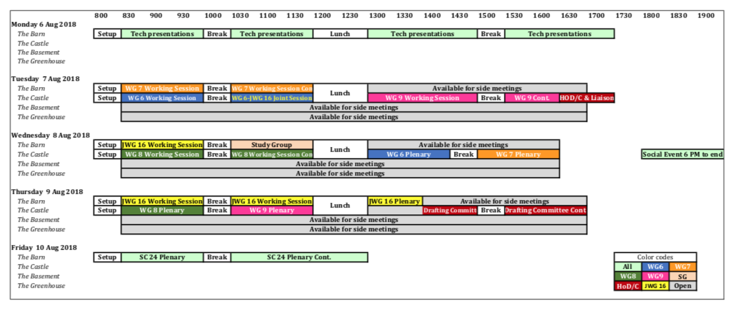
Back to Top

