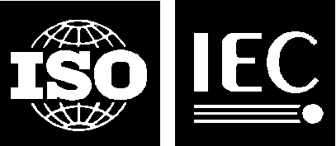 |  | ISO/IEC JTC1/SC24 WG8 N0643

Our ref.: GW

Date: 29 August 2019

Secretariat of ISO/IEC JTC 1/SC 24 WG 8
Environmental Representation

Title: SEDRIS Organization Liaison Report to SC 24 and
WG 8

Source: Mamaghani

Replaces: WG 8 N0633

Document Type: Liaison Report

Projects: ISO/IEC 18023 – 18026, 18041, 18042, 9973

Status: Submitted to SC 24 and WG 8

Action ID: FYI

Due Date: N/A

Distribution: WG 8 Members, SC 24 Secretariat, SC 24 Chairman and
WG Convenors

Date of Distribution: 29 August 2019

Distribution Medium: Web

Batch No: 8/D386

No of pages: 2 (+1 cover page)

