Draft WG 8 Agenda

For the 2020 WG8 Meetings

As a result of the instruction issued by ISO, dated 2020-06-05, the measures in place during the Covid-19 crisis have been extended to 30 September 2020. This means that the face-to-face SC 24 Plenary meetings planned for 27-31 July 2020 in Florida Fl., USA will now be held as a series of web-meetings over the period 27/28 July to 17/18 August 2020 (see Annex A).

Each web meeting will be limited to 2 hours, so it is important for the agenda to be agreed before the meeting starts. With this in mind, this document informs you of the draft agenda for the 2020 WG 8 Working Session and Plenary.
If no comments are received by jack.cogman@datasim.net by 19 June 2020, it will be issued as part of a Meeting Plan and Agenda document.

WG 8 Environmental Data Representation

On-line Working Session 2020

Agenda

Monday/Tuesday 3/4 August 2020
07:00 – 09:00 Tuesday 4 August: Australia (East Coast)
06:00 – 08:00 Tuesday 4 August: Japan
06:00 – 08:00 Tuesday 4 August: Korea
05:00 – 07:00 Tuesday 4 August: Beijing (China Standard Time)
23:00 – 01:00 Monday/Tuesday 3/4 August: France
22:00 – 23:59 Monday 3 August: UK
17:00 – 19:00 Monday 3 August: USA (East Coast)
14:00 – 16:00 Monday 3 August: USA (Pacific)

Chair: Jack Cogman
- Welcome and Introductions
- Current Work Schedule:
- 18041-5 EDCS LB to C++
- 18042-5 SRM LB to C++
- 18024-5 SEDRIS Part 1 LB to C++
- Proposed SEDRIS Part 1 LB to XML
- Update on SISO RIEDP Products and Standards
- SISO EDRS Product Support Group
- EDCS Registry
- SC 24 Road Map
- Current status of Action Items
- Review of the planned WG 8 work programme
- Draft recommendations to be forwarded to the WG 8 Plenary meeting

Back to the Top
WG 8 Environmental Data Representation
On-line Meeting 2020

36th Plenary Agenda

Monday/Tuesday 10/11 August 2020
07:00 – 09:00 Tuesday 11 August: Australia (East Coast)
06:00 – 08:00 Tuesday 11 August: Japan
06:00 – 08:00 Tuesday 11 August: Korea
05:00 – 07:00 Tuesday 11 August: Beijing (China Standard Time)
23:00 – 01:00 Monday/Tuesday 10/11 August: France
22:00 – 23:59 Monday 10 August: UK
17:00 – 19:00 Monday 10 August: USA (East Coast)
14:00 – 16:00 Monday 10 August: USA (Pacific)

Chair: Jack Cogman
- Welcome and introductions
- Approval of the minutes of the 35th meeting held at Takamatsu, Japan 2019
- Convenor's report
- Summary of key topics from the Working Session
- National Body reports
- Liaison reports
- SEDRIS
- SISO
- Any other liaison reports
- Editor reports
- Reports from the registry rapporteurs
- Appointment of registry rapporteurs
- EDCS
- SRM
- SEDRIS
- Summary of WG 8 content in the draft SC 24 Business Plan for 2020-21
- Work Schedule
- Review and approval of WG 8 Recommendations to SC 24
- Review action items
- Adjourn
Back to the Top
Annex A

SC 24 On-line Meeting Plan 2020

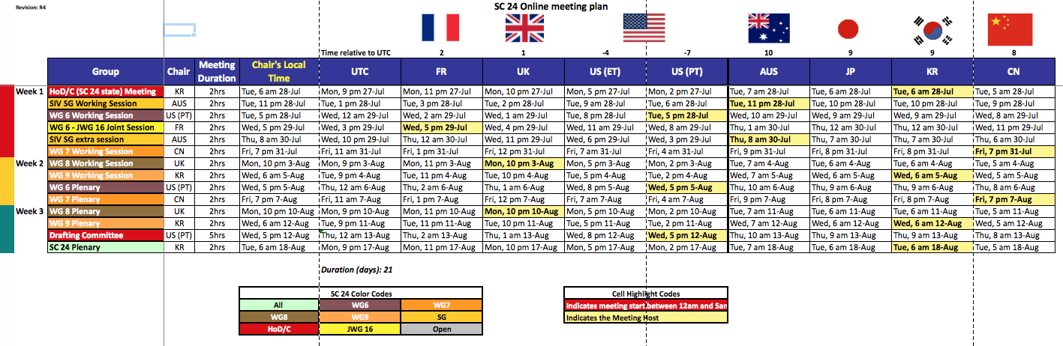

Back to Top

