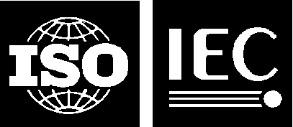 |  | ISO/IEC JTC1/SC24 WG8 N0660

Our ref.: GW
Date: 6 February 2022

Secretariat of ISO/IEC JTC 1/SC 24 WG 8
Environmental Representation

Title: Updates on 18024-5
37th SC 24/WG 8 Meeting, July 2021, On-line Web Meetings

Source: Lee

Replaces: N/A

Document Type: Meeting Presentation

Projects: ISO/IEC 18023 - 18026, 18041, 18042, 24788

Status: Submitted to SC 24 and WG 8

Action ID: FYI

Due Date: N/A Members, SC 24 Secretariat, SC 24 Chairman and WG Convenors

Date of Distribution: 6 February 2022

Distribution Medium: Web

Batch No: 8/D397

No of pages: 8 (+1 cover page)

